Adventist University of Central Africa

Market SpotOn System
(Space Management Platform)

Case study: Gasabo Investment Company (GIC)

A final Year Project Presented in partial fulfillment of the requirements for the degree of BACHELOR OF SCIENCE IN INFORMATION TECHNOLOGY

Major in

Networks and Communication Systems

By Shema Hugues February, 2026

ABSTRACT
A final year project for the Bachelor’s Degree of Science in Information Technology Emphasis in Networks and Communication Systems
Adventist University of Central Africa

TITLE: Market SpotOn System
Name of the Researcher: SHEMA Hugues
Name of faculty Advisor: Mr. Nsengiyumva Juvenal
Date Completed: February, 2026

The Market SpotOn System is a web-based platform developed to modernize market management in Gasabo District. It replaces manual processes with digital tools for managing market spaces, payments, and communication. The system provides a centralized solution that improves coordination, transparency, and efficient monitoring of market activities, creating a more organized and technology-driven environment.

The current manual system uses paper records, physical space allocation, and cash payments, which lead to delays, errors, and poor data management. Market administrators face difficulties in tracking occupancy, monitoring payments, and generating accurate reports. The lack of real-time information and integrated communication reduces accountability and limits effective decision- making.

Data were collected through observation, interviews, and review of market administrative documents. System design followed an object-oriented approach using UML diagrams. The system was implemented using React.js, Node.js, and MySQL, ensuring a scalable and maintainable architecture.

This integrated market management system centralizes space allocation, seller management, payment processing, reporting, and communication into a single secure platform. It improves operational efficiency, enhances data accuracy, and supports the transition from manual processes to a modern, fully digital, and well-coordinated market management environment.

DECLARATION

I, SHEMA Hugues Student ID Number 25603, a student at the Adventist University of Central Africa in the Faculty of Information Technology, Department of Networks and Communication Systems, do hereby declare that this final year project report entitled “Market SpotOn System” is entirely the real reflection of my own original work and experience to the best of my knowledge. It has never been either partially or wholly presented in any university or any higher learning institution for the award of a degree or any other qualification.
Signature: ………………………….

Date: …………/…………/….……...

APPROVAL

I, NSENGIYUMVA Juvenal, hereby certify that student Shema Hugues, with
registration number 25603, in the Faculty of Information Technology, Department of Networks and Communication Systems, has completed this Final Year Project report under my supervision and is hereby submitted with my approval.
Signature: ………………………………….

Date: …………/…………/…………………

DEDICATION
To my parents,

To my beloved sisters and brothers, To my classmates, friends, and relatives,
To my supervisor for his guidance I dedicate this final report

Table of Contents

ABSTRACT i
DECLARATION ii
APPROVAL iii
DEDICATION iv
LIST OF FIGURES vii
LIST OF TABLES viii
LIST OF ABBREVIATION ix
ACKNOWLEDGMENTS x
CHAPTER 1 GENERAL INTRODUCTION 1
Introduction 1
Background of the Study 2
Choice and Motivation of the Study 5
General Objective 6
Specific Objectives 6
Methodology and Techniques used in the Study 8
Observation 8
Interview 8
Expected Results 10
Organization of the Work 11
CHAPTER 2 ANALYSIS OF THE EXISTING SYSTEM 12
Introduction 12
Description of the Existing System Environment 13
Historical Background 13
Mission 13
Vision 13
Modelling of the current System 17
Proposed Solutions 21
System Requirements 22
CHAPTER 3 25
REQUIREMENT ANALYSIS AND DESIGN OF THE NEW SYSTEM 25
Introduction 25
Description of the New System 26
Use Case Diagram 27
Class Diagram 36
Class Diagram 37
Database Schema Diagram 46
Data Dictionary 47
CHAPTER 4 51
IMPLEMENTATION OF THE MARKET SPOTON SYSTEM 51
Introduction 51
Technologies Used 52
Front-End Development 52
Back-End & Database Development 53
Presentation of the New System 54
Software Testing 57
Hardware and Software Requirements 58
Client-Side Software Requirements 58
Server-Side Software Requirements 58
CHAPTER 5 59
CONCLUSION AND RECOMMENDATIONS 59
Conclusion 59
Recommendations 60
REFERENCES 61
Books 61
Reports and Journal Articles 62
APPENDICES 63
Curriculum Vitae 64
Data Collection Letter 65
Case study organisation Approval Letter 66

LIST OF FIGURES
Figure 1Current Sytstem model 17
Figure 2Use case diagram 30
Figure 3 Class diagram 37
Figure 4 Sequence Diagram 40
Figure 5Prediction sequence diagram 41
Figure 6User signup and login activity diagram 44
Figure 7 Prediction activity diagram 45
Figure 8 Database schema 46
Figure 9 System architecture 50
Figure 10 Login Page 54
Figure 11 Admin Dashboard 55
Figure 12 Zone Page 55
Figure 13 Space Management Page 56
Figure 14 Report 56

LIST OF TABLES
Table 1Adding users Use Case Table 32
Table 2 Admin Use Case Table 34
Table 3Backend side Table 36
Table 4Sequence diagram Table 39

LIST OF ABBREVIATION

API. | Application Programming Interface
GIC | Gasabo investment Company
AUCA | Adventist University of Central Africa
CSV | Comma-Separated Values
AI | Artificial Intelligence
DBMS | Database Management System
HTTP | Hypertext Transfer Protocol
ICT | Information and Communication Technology
IT | Information Technology
SQL | Structured Query Language
UI | User Interface
NST. | National Strategy Transformation

ACKNOWLEDGMENTS
First and foremost, I would like to express my sincere gratitude to the Almighty God for His blessings, wisdom, and unwavering guidance throughout the journey of this project. His grace has been my strength and inspiration in every phase of this work, and I am eternally thankful for His divine presence in my life.
I would like to express my sincere appreciation to AUCA and its entire administration and academic staff for their support and guidance throughout my studies. Special thanks go to the Faculty of Information Technology, particularly the Department of Networks and Communication Systems, for their valuable knowledge, resources, and academic support. The high-quality education I received at AUCA has been instrumental in my academic growth and has greatly contributed to the successful completion of this project.
I wish to extend my heartfelt thanks to my project supervisor, Mr. Nsengiyumva Juvenal, for his invaluable mentorship, expert guidance, and immense patience. His insightful feedback, constant encouragement, and scholarly advice were crucial in shaping the "Market SpotOn System" from a concept into a realized project.
I am profoundly grateful to my beloved parents for their unconditional love, endless support, and steadfast encouragement. Your belief in my abilities and the countless sacrifices you have made form the bedrock of my achievements. Thank you for always being my pillars of strength.
I am also thankful to my friends and classmates at AUCA for their camaraderie, collaborative spirit, and moral support throughout our studies. The stimulating discussions and shared experiences have made this academic journey both memorable and rewarding.

Finally, I would like to sincerely thank everyone who contributed to this work, directly or indirectly. Your support, guidance, and encouragement were invaluable, and I am deeply grateful.

May God bless you all abundantly

SHEMA Hugues

CHAPTER 1 GENERAL INTRODUCTION

Introduction

Advancements in information technology have changed how organizations manage their operations, encouraging the adoption of digital systems that improve efficiency, accuracy, and service delivery. Despite this progress, many traditional markets still rely heavily on manual procedures for handling essential activities such as registering vendors, assigning selling spaces, collecting payments, and preparing operational reports. These paper-based methods often result in slow processes, difficulties in tracking records, limited transparency, and challenges in maintaining accurate financial and administrative data.

Market administrators frequently encounter problems when trying to monitor space availability, verify payment records, or generate timely reports for planning and decision-making. At the same time, vendors may experience delays during registration, lack immediate confirmation after payments, and have limited access to up-to-date information regarding their allocated spaces or account status. Such inefficiencies not only affect daily market operations but can also lead to revenue losses and reduced trust between vendors and market authorities.

To overcome these challenges, the Market SpotOn System is introduced as a digital platform designed to automate and simplify market management activities. The system provides a centralized environment where administrators can manage zones and spaces efficiently, register vendors electronically, monitor payments in real time, and automatically generate operational reports. Vendors benefit from the ability to access their information online, complete payments through integrated digital payment services, and receive instant notifications related to their transactions and market announcements.

The adoption of this system is expected to reduce manual workload, improve data accuracy, and strengthen transparency in market operations. With real-time access to reliable information, administrators will be able to make more informed decisions and respond quickly to operational needs.

Background of the Study

Public markets have historically played a central role in supporting local economies, particularly in developing countries where small scale trade represents a major source of employment and income. These markets provide opportunities for entrepreneurs, farmers, and informal traders to sell goods and services while also ensuring that communities have access to essential products at affordable prices. Because of their economic and social importance, effective market management is necessary to maintain order, ensure fair allocation of resources, and support sustainable revenue collection for local authorities. However, in many regions, the administration of public markets still relies heavily on traditional manual systems that were originally designed for smaller populations and less complex market activities. (International Labour Organization, 2018; World Bank, 2019; UN-Habitat, 2015)

Manual market management typically involves paper based seller registration, handwritten payment receipts, manual assignment of selling spaces, and physical storage of administrative records. While these practices may appear simple, they often lead to a range of operational challenges. Records can easily be misplaced or damaged, updating information requires significant time and effort, and verifying the accuracy of data becomes difficult when multiple records are handled manually. As markets grow and the number of traders increases, these challenges become more pronounced, leading to delays in service delivery, inefficiencies in daily operations, and difficulties in tracking revenue collection. In addition, the absence of centralized digital records limits the ability of administrators to generate timely and reliable reports, which are essential for planning, monitoring performance, and making informed decisions.

The rapid advancement of information and communication technologies (ICT) has introduced new opportunities for improving administrative systems across different sectors. Around the world, organizations are adopting digital platforms to automate routine processes, enhance data accuracy, and improve communication between stakeholders. Electronic management systems allow real- time monitoring of activities, automated record keeping, and faster generation of analytical reports. Such systems not only reduce administrative workload but also increase transparency and accountability by ensuring that information is stored securely and can be accessed whenever needed.

In Rwanda, the government has demonstrated a strong commitment to promoting digital transformation through national initiatives such as Vision 2050, the National Strategy for Transformation (NST), and the Smart Rwanda Master Plan. These initiatives emphasize the use of technology to enhance service delivery, strengthen governance, and support sustainable economic development. Significant progress has already been made in sectors such as banking, education, healthcare, and public administration, where digital systems are increasingly being used to manage services and transactions. Despite these advancements, some areas of local administration, including the management of public markets, still rely on manual or semi-digital processes that limit efficiency and transparency.

From the vendors’ perspective, manual systems can also create inconveniences. Registration procedures may require multiple visits to administrative offices, payment confirmations may take time to process, and accessing updated information about allocated spaces or outstanding payments may not always be straightforward. Such challenges can affect business operations, reduce confidence in administrative processes, and create unnecessary delays for traders who rely on efficient services to maintain their daily activities. As markets continue to expand and the demand for efficient services increases, the need for a more reliable and technology-driven management approach becomes increasingly evident.

It is within this context that the Market SpotOn System is proposed as a comprehensive digital solution aimed at improving the management of public markets. The system is designed to provide an integrated platform where administrators can oversee zones and selling spaces, register vendors electronically, monitor payments through secure digital channels, and generate automated reports to support planning and decision-making. Vendors, in turn, can access their personal accounts, view their allocated spaces, make payments electronically, and receive timely notifications regarding their transactions and market-related updates.

By replacing fragmented manual procedures with an automated and centralized system, the Market SpotOn System is expected to significantly enhance operational efficiency, data accuracy, and transparency in market administration. The system will help reduce paperwork, minimize human errors, and ensure that reliable information is readily available for both administrators and vendors.

Statement of Problem

Current market management methods are largely inefficient, relying on manual processes for space allocation, seller registration, and payment collection, leading to operational delays, revenue leakage, and poor resource utilization. Many market authorities still depend on paper-based records and physical oversight, which fail to provide real-time visibility into space occupancy, financial tracking, and vendor management. These outdated practices are inadequate for modern market demands, especially in rapidly growing urban centers where efficiency and transparency are crucial. The main challenges that characterize existing market management systems include:
Inefficient space allocation: Manual allocation processes often lead to either under-utilization of market spaces or conflicts over space distribution, both of which affect market operations and revenue generation.
Lack of real-time data: Market administrators lack access to up-to-date information on space occupancy, payment status, and vendor records, hindering effective decision-making and resource management.
Limited financial transparency: Without integrated digital payment systems, cash-based transactions make it difficult to track and reconcile market revenues, leading to potential revenue losses and accountability issues.
Administrative inefficiency: The reliance on manual processes creates significant administrative overhead, delays in vendor onboarding, and difficulties in maintaining accurate records of market operations.

Poor communication and notification systems: Sellers often miss important updates regarding available spaces, payment deadlines, or market regulations due to the lack of automated communication tools, leading to missed opportunities and operational confusion.

Difficulty in performance monitoring and reporting: Without digital systems, tracking vendor performance, occupancy rates, and revenue trends requires extensive manual effort, making it hard for market authorities to identify inefficiencies, plan improvements, or generate timely reports for decision-making.

Choice and Motivation of the Study
The motivation behind the Market SpotOn System is to provide a comprehensive digital platform that streamlines market management by integrating real-time space monitoring, automated vendor registration, and secure digital payment processing. By doing so, the Market SpotOn System aims to reduce administrative burdens, enhance financial transparency, and optimize resource utilization, addressing the fundamental challenges of traditional market management while promoting sustainable and accountable trading environments.
To AUCA: Developing the Market SpotOn System provides a practical opportunity to apply the knowledge and skills I have gained during my Bachelor of Science in Information Technology studies at the Adventist University of Central Africa (AUCA). This project integrates system design, web development, and data-driven analytics, aligning with AUCA’s mission of nurturing innovative professionals who leverage technology to solve real-world problems and promote efficient, community-centered digital transformation.
To the Gasabo Investment Company: SpotOn System directly supports Rwanda’s efforts to modernize market operations and empower local vendors to participate actively in the economy. By providing a centralized digital platform for space allocation, payment management, communication, and reporting, the system improves operational efficiency, transparency, and accountability.
The platform also aligns with Rwanda’s Vision 2050 and the National Strategy for Transformation (NST2) by promoting inclusive digital innovation, data-driven management, and enhanced citizen engagement. Furthermore, it contributes to the Smart Rwanda Master Plan by leveraging ICT to strengthen vendor participation, streamline market operations, and improve the overall management of community-based commercial activities.
To the Student: This project represents both an academic and personal commitment to applying technology for practical impact. As a student specializing in Networks and Communication Systems, I was inspired by the challenges faced in managing traditional market operations efficiently. The Market SpotOn System enabled me to transform theoretical knowledge into a real- world solution that promotes digital inclusion, streamlines market processes, and supports Rwanda’s innovation and development agenda.

Objectives of the Study

General Objective
To develop a digital platform that streamlines market management by automating space allocation, vendor management, and payments through real-time data integration. The system will provide market authorities with tools for efficient operations, transparency, and accountability, using cloud computing and analytics to generate actionable insights. Automated notifications and updates will guide administrators and vendors, reducing delays and financial discrepancies. Accessible via web and mobile applications, the platform aims to lower administrative costs, improve vendor satisfaction, and create more organized, sustainable markets.

Specific Objectives:

- To develop a secure, web-based, and mobile-responsive platform that enables market administrators and sellers to register, allocate spaces, and manage payments in real time, reducing reliance on manual and paper-based processes.
- To design an intuitive and user-friendly interface that accommodates both administrators and sellers, ensuring ease of use, accessibility, and wider adoption across different market users.
- To build a robust database system for securely storing and managing seller profiles, space allocation records, payment histories, and market operations efficiently.
- To integrate intelligent algorithms to optimize space allocation, match sellers with available spaces, and provide insights for better utilization and revenue maximization.
- To implement a real-time communication and notification system that alerts sellers about available spaces, payment reminders, and important market updates.
- To provide analytical dashboards and automated reporting tools that allow market authorities to monitor occupancy, track payments, evaluate performance, and make data- driven decisions.
- To ensure data security, privacy, and system reliability by implementing authentication, authorization, and encryption mechanisms to protect sensitive user information and financial data.

Scope of the Study
The Market SpotOn System will focus on small to medium-scale market administrations, providing a comprehensive digital management platform that integrates space allocation, vendor registration, payment processing, and communication features. By optimizing existing market operations, the platform will help market authorities manage resources efficiently and make data- driven decisions regarding space utilization and revenue collection. In addition to providing operational insights, the system will track occupancy rates, payment compliance, and vendor activity, promoting transparent market management without requiring significant infrastructure changes.
Rather than developing new physical market infrastructure or implementing complex hardware systems, the primary goal of the Market SpotOn System is to enhance operational efficiency using digital solutions. By leveraging real-time data and automated workflows, the platform will support market administrations in adopting modern management practices, ultimately reducing administrative burdens and improving vendor satisfaction. This approach ensures accessibility and practicality for small to medium-scale markets while contributing to long-term organizational sustainability.
The study will concentrate on developing the core software platform and its essential modules, including:
- Digital space mapping and allocation system

- Vendor registration and management portal

- Mobile money and digital payment integration

- Automated reporting and notification features

The implementation will utilize existing technological infrastructure commonly available in market environments, focusing on web and mobile accessibility to ensure broad usability.

Methodology and Techniques used in the Study
The research methodology for the Market SpotOn System will adopt a systematic approach to analyzing and improving market management processes. This will include both qualitative and quantitative techniques, such as literature review, direct observation of market operations, surveys with market administrators and vendors, and case studies of existing digital management systems. These methods will help gain a comprehensive understanding of current market management practices, identify operational inefficiencies, and develop solutions to optimize market operations through digital transformation.

Documentation
Documentation is a research method that involves the systematic collection, review, and analysis of existing records, reports, and written materials relevant to the study topic. It allows researchers to understand background information, identify operational challenges, and gather evidence to support research objectives.
In this study, I used documentation review to examine existing records, reports, and policies from local markets, vendor associations, and government agencies overseeing commerce in Kimironko Market. This included analyzing current market space allocation records, payment logs, vendor registration forms, and reports on market operations and management.

Observation
Observation is a qualitative research method that involves directly monitoring and recording behaviors, processes, and interactions in a real-world setting without interference. In the context of the Market SpotOn System, observation will be used to study how market administrators currently manage space allocation, vendor registration, and payment collection. This method allows researchers to collect objective data on administrative workflows, decision-making patterns, and operational challenges affecting market management efficiency.

Interview
Interview are a qualitative research method used to gather in-depth insights from individuals with relevant knowledge and experience. They involve structured, semi-structured, or open-ended discussions to explore perspectives, challenges, and potential solutions related to a specific topic. In the context of the Market SpotOn System, interviews will be conducted with market.

I, Hugues Shema, a finalist in the Faculty of Information Technology, Department of Networks and Communication Systems at the Adventist University of Central Africa (AUCA), conducted this research to design and develop Market SpotOn System, specifically addressing inefficiencies in market space allocation, vendor registration, payment processing, and reporting.

Question 1: What challenges do you currently face in managing market operations? Answer: The main challenges include inefficient allocation of selling spaces, difficulty in tracking vendor payments, lack of real-time information on space occupancy, and limited communication with vendors. These challenges often lead to administrative delays, disputes over space usage, and loss of potential revenue.

Question 2: How effective are the current tools and methods used for market management? Answer: The current tools and methods are mostly manual, relying on paper-based records and physical supervision. While they have been used for a long time, they are inefficient, prone to errors, and unable to provide real-time visibility into market operations such as vendor registration, payment tracking, and space monitoring.

Question 3: What improvements are needed to enhance market management practices? Answer: There is a strong need for digital solutions that automate key processes such as space allocation, vendor registration, and payment collection. Improving transparency, reducing manual workload, and enabling real-time reporting are essential for effective and efficient market management.

Question 4: What features do you expect from a new market management system? Answer: The expected features include real-time monitoring of market spaces, automated vendor registration, integrated digital payment systems, detailed reporting on occupancy and revenue, and effective communication tools between market administrators and vendors.

Question 5: How would a digital market management system benefit market operations? Answer: A digital system would improve operational efficiency, increase revenue transparency, reduce errors, and support better decision-making through real-time data and reports.

Expected Results

The Market SpotOn System is expected to effectively address the challenges identified in the objectives of this project. After successful implementation,

Improved Market Space Management: The system will enable efficient digital allocation and monitoring of market zones and selling spaces. This will reduce conflicts over space ownership, eliminate duplication, and ensure optimal utilization of available market infrastructure.

Enhanced Transparency and Accountability: By digitizing seller registration, space allocation, and payment processes, the system will promote transparency between market authorities and sellers. All transactions and allocations will be traceable, reducing disputes and opportunities for mismanagement or corruption.

Improved Revenue Collection: Integration of secure mobile money and digital payment systems will streamline fee collection. Automated receipts and reconciliation will minimize revenue leakage, ensure timely payments, and improve financial accountability for market management authorities.

Faster Communication and Notifications: The system will facilitate instant communication through automated notifications such as payment reminders, allocation updates, and important announcements. This will improve information flow and reduce delays associated with manual communication methods.

Data-Driven Decision Making: Automated daily, weekly, and monthly reports will provide market administrators with real-time insights into occupancy rates, payment status, and overall market performance. This will support informed planning, policy formulation, and operational decision-making.

Enhanced Vendor Satisfaction and Market Efficiency: By simplifying registration, space allocation, and payment processes, the system will reduce administrative burdens for vendors, improve their overall experience, and contribute to a more organized and smoothly functioning market environment.

Organization of the Work
This research study comprises five chapters, each serving a distinct purpose in the development and analysis of the Market SpotOn System:
Chapter One: General Introduction, provides a general overview of the project, including the background of the study, problem statement, motivation, objectives (general and specific), scope of the system, methodology, requirements collection techniques, and expected results.

Chapter Two: Analyzes the existing System, manual market management system, identifies its weaknesses, and defines the requirements of the proposed Market SpotOn System. It includes functional and non-functional requirements, use-case descriptions, system overview, logical data models, and expected system benefits.

Chapter three: Requirement analysis and design of the new system, Presents the system design, including the high-level system architecture, module descriptions, and overall solution design. It also covers process models, physical data models, class diagrams, use-case diagrams, and user interface designs.
Chapter Four: Implementation of the market spoton system, Focuses on the implementation phase of the system. It describes the tools and technologies used, system development, coding practices, database implementation, and testing procedures applied to ensure system reliability and performance.
Chapter five: Conclusion and recommendations, summarize the project, highlights achievements, discusses limitations encountered during development, and proposes possible future enhancements to improve the market spoton system.

CHAPTER 2
ANALYSIS OF THE EXISTING SYSTEM

Introduction

This chapter provides a comprehensive analysis of the existing market management systems and lays the foundation for the development of the Market SpotOn Market System. The primary objective of this section is to examine current market practices, identify operational challenges, and demonstrate how SpotOn can address these gaps to enhance efficiency, transparency, and overall management.

The Market SpotOn System is designed to streamline the administration of marketplaces by providing a centralized digital platform for vendors, administrators, and managers. Its core functionalities include the automated allocation of market spaces, integration of mobile money payment systems, real-time monitoring of vendor transactions, generation of operational reports, and communication tools that keep all stakeholders informed. By leveraging these features, SpotOn aims to reduce human error, minimize operational delays, and create a more transparent and accountable marketplace environment.

Current market management practices, particularly in traditional settings, often rely on manual processes, such as paper-based records for space allocation and payment tracking. These methods are prone to inefficiencies, including lost or inaccurate records, delayed payments, and difficulties in monitoring vendor compliance. Vendors also face challenges such as unclear allocation schedules, lack of timely notifications, and limited access to transactional records, which can result in misunderstandings and reduced trust in market administration. From a revenue management perspective, these inefficiencies contribute to financial leakage and hinder optimal utilization of available resources.

The Market SpotOn System proposes solutions that address these limitations. By centralizing vendor information, automating payment and allocation processes, and providing real-time dashboards, the system enhances operational efficiency, promotes accountability, and ensures accurate financial management.

Description of the Existing System Environment Historical Background
Gasabo Investment Company Ltd (GIC) was established in 2013 through an initiative of the Private Sector Federation (PSF) in Gasabo District, in collaboration with district authorities. The company was founded as a public–private partnership aimed at stimulating local economic development, mobilizing community investment, and promoting shared prosperity among residents of Gasabo District.

Since its establishment, GIC has focused on identifying and exploiting viable investment opportunities within the district, particularly in sectors such as real estate development, market modernization, energy, agriculture, and transport infrastructure. One of its earliest strategic goals was to encourage residents to participate in economic development by buying shares, thereby directly benefiting from local investments.

Among GIC’s major initiatives is the modernization of Kimironko Market and the Kimironko Bus Terminal, projects designed to address congestion, improve service delivery, and enhance the overall commercial environment. These projects represent a significant investment portfolio valued at over USD 100 million, positioning GIC as a key driver of urban transformation and community-oriented development in Gasabo District.

Mission
The mission of Gasabo Investment Company Ltd is to stimulate sustainable economic growth and shared prosperity in Gasabo District by mobilizing local investment, strengthening public–private partnerships, and developing modern, inclusive, and income-generating infrastructure projects that benefit residents, investors, and government institutions.

Vision
The vision of Gasabo Investment Company Ltd is to become a leading community-driven investment company that transforms Gasabo District into a modern, well-organized, and economically vibrant urban hub, while contributing to national development goals such as Vision 2050 through job creation, innovation, and sustainable urban development.

Description of the current System
At present, the market management system in many local marketplaces, including those under the Gasabo District administration, operates entirely manually. Market space allocation, rental payments, and vendor tracking are handled using paper-based records, physical registers, and verbal communication. Market administrators assign spaces to vendors and collect payments in person, while vendors rely on visiting offices or contacting administrators directly to access services.

Information about available market spaces, payment deadlines, or announcements about market regulations is usually shared through notice boards, community meetings, or word of mouth. Vendors who wish to rent a space or update their payment information must travel to the market offices, often resulting in long queues and delays. After payments are made, records are updated manually, and reports summarizing space allocations, payments, and vendor participation are prepared by hand.

This manual approach creates multiple challenges. Coordination between market administrators, vendors, and other stakeholders, such as local authorities, relies heavily on phone calls or in-person follow-ups, which are time-consuming and prone to errors. There is no centralized system to monitor space availability, track payments, or provide real-time updates, making it difficult to manage market operations efficiently or ensure timely communication with vendors.

Furthermore, manual record-keeping makes it difficult to maintain accurate data over time. Lost or misplaced documents, inconsistent reporting, and delayed consolidation of payment and space allocation records are common problems. As a result, administrators struggle to generate reliable reports or analyze market trends to inform decision-making.

The current market management system faces several critical challenges that limit efficiency, transparency, and service quality:

Manual Space Allocation and Payment Management: Administrators allocate market spaces and track payments on paper. This process is slow, prone to errors, and difficult to scale as the number of vendors increases. Vendors may face delays in obtaining confirmations for their rented spaces.

Delayed Communication and Vendor Updates: Announcements about available spaces, payment deadlines, or market rules are shared through notice boards, meetings, or phone calls. This informal communication often leads to missed notifications or inconsistent information, reducing vendor participation and satisfaction.

Lack of Real-Time Tracking: There is no system to monitor space occupancy or payment status in real time. Administrators rely on repeated in-person checks and phone calls, while vendors have limited visibility into their account or payment status.

Poor Data and Document Management: Records of vendors, space allocations, and payments are stored physically, making them vulnerable to loss, duplication, or damage. This compromises the accuracy and reliability of market data.

Inefficient Coordination Among Stakeholders: Communication between administrators, vendors, and local authorities is informal and inconsistent. Without a structured system, follow- ups on overdue payments, vacant spaces, or vendor compliance are slow and error-prone.

Limited Reporting and Analytics: Reports on payments, space occupancy, and vendor activity are prepared manually, lacking depth and analytical insights. Decision-making is hindered by the absence of a centralized system capable of tracking trends, monitoring performance, or generating data-driven insights.

Analysis of the Current System

At Gasabo Investment Company (GIC), market operations such as space allocation, seller registration, payment collection, reporting, and communication are still largely managed through manual or semi-digital processes. These fragmented approaches limit operational efficiency and make it difficult to manage large and busy facilities such as markets and terminals effectively. The absence of a centralized digital system results in inconsistent records, duplication of data, and delays in accessing accurate information.

Decision-making within GIC is often slowed by the lack of real-time data on space occupancy, seller compliance, and payment status. Generating operational or financial reports requires manual compilation, which is time-consuming and prone to errors. This limits management’s ability to monitor performance, optimize space utilization, and plan strategically.

Revenue collection also faces challenges due to non-integrated payment tracking mechanisms. Without automated reconciliation and instant confirmation, monitoring payments becomes difficult, increasing the risk of delays, disputes, and revenue leakage. In addition, communication between GIC management and market sellers relies heavily on verbal notices or printed announcements, which are not always timely or reliable. This communication gap contributes to missed payments, misunderstandings, and reduced transparency.

Furthermore, the lack of an integrated dashboard makes it difficult for administrators to oversee market operations holistically, while sellers have limited access to their own allocation and payment information. These challenges reduce accountability and weaken trust between GIC and market stakeholders.

The key challenges faced by the existing system at GIC include:

Delayed Decision-Making: Absence of real-time, centralized data on space allocation, occupancy, and payments.

Inefficient Space and Seller Management: Manual registration and allocation processes leading to errors and poor spaace utilization.

Weak Revenue Monitoring: Lack of integrated digital payment tracking and automated reconciliation.

Poor Communication: Ineffective dissemination of payment reminders, allocation updates, and announcements.

Limited Transparency and Reporting: Inadequate reporting tools for monitoring performance and supporting strategic planning.

Modelling of the current System
The current market management system operates primarily through manual processes. Market authorities rely on paper-based records and physical oversight to register sellers, allocate spaces, and collect payments. Space allocation is often inconsistent, leading to under-utilization or conflicts among vendors. Payment tracking is conducted in cash, making reconciliation difficult and increasing the risk of revenue loss. Communication with vendors is largely informal, causing delays in updates and notifications. Overall, the existing system lacks real-time visibility, automated reporting, and centralized data management, resulting in operational inefficiencies, limited transparency, and challenges in decision-making.
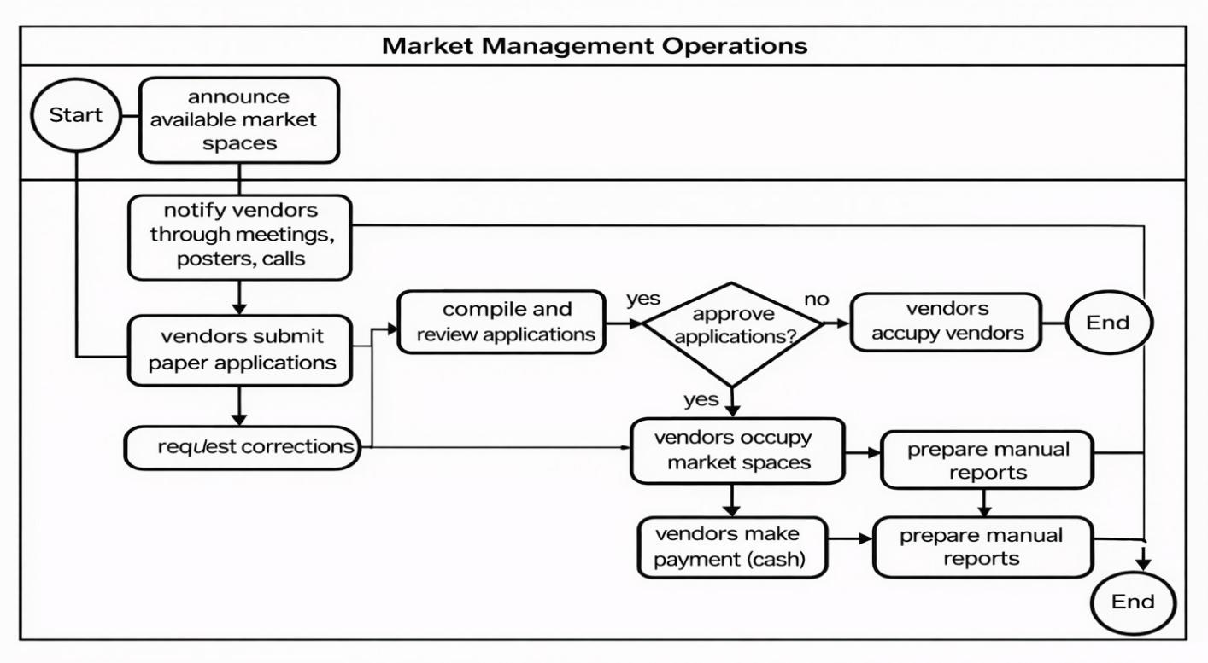
Figure 1. Current System model

The current process of managing market spaces, payments, and vendor participation in the Kimironko Market operates entirely manually. The workflow can be described in several sequential steps:

Step 1: Announcement of Available Market Space
The Market Administration Office or partnering authorities initiates the process by announcing available market spaces, rental terms, and payment schedules. These announcements are communicated through notice boards, local meetings, or phone calls to community leaders and vendor representatives.

Step 2: Communication to Vendors
Community leaders or market coordinators receive the details of available spaces and disseminate the information to vendors using public gatherings, posters, or word of mouth. While this ensures that vendors are informed, the method is often slow, inconsistent, and prone to miscommunication.

Step 3: Vendor Registration and Space Application
Vendors who wish to rent a market space must manually record their details on paper forms maintained by market coordinators. These forms include personal and business information, preferred space location, and intended duration of rental. The paper forms serve as the primary record for vendor registration.

Step 4: Compilation of Applications
Market coordinators collect and verify the registration forms, compile vendor lists, and submit them to the Market Administration Office for approval. This manual compilation is time consuming and prone to inconsistencies, especially when handling large numbers of vendors.

Step 5: Review and Verification
The Market Administration Office reviews the submitted applications to confirm eligibility, space availability, and completeness of the data. Incomplete or unclear applications require follow-ups through phone calls or in-person visits, delaying the approval process.

Step 6: Approval and Notification
Once verified, approved vendors are confirmed for their allocated market spaces. Notifications are communicated manually through phone calls or community meetings, often resulting in delays or missed messages for some vendors.

Step 7: Space Occupancy and Activity Monitoring
Vendors occupy their allocated market spaces under the supervision of market coordinators. Coordination during daily operations is mostly verbal, and there are no digital tools to track space usage, vendor attendance, or compliance with market regulations.

Step 8: Payment Recording
Payments are collected in person, usually in cash, and recorded manually in ledgers. The manual recording process increases the risk of errors, lost receipts, and delayed confirmation of payment status.

Step 9: Reporting and Record-Keeping
Market coordinators summarize rental and payment records, preparing manual reports that are submitted to the Market Administration Office for review and filing. The lack of a centralized system limits the ability to track vendor participation history, generate analytics, or monitor market trends efficiently.

Problem of the Existing System

Current market management in many urban centers relies heavily on manual processes, including paper-based records, physical oversight, cash payments, and informal communication methods such as phone calls or WhatsApp messages. These practices create inefficiencies, delays, and weak coordination between market authorities and vendors. Using the PIECES framework, the main challenges can be summarized as follows:

Performance

- Manual allocation of market spaces and vendor registration slows operations and often leads to conflicts or underutilization of available spaces.

- Payment collection and record-keeping are done manually, increasing the chance of errors, lost revenue, and delays in financial reporting.

Information

- Vendor and space data are inconsistently recorded, with no standardized digital forms or automated validation.
- Reports on occupancy, payments, and market activity are manually prepared, offering no real-time updates or dashboards.
- Data is scattered across paper files, spreadsheets, and informal messages, increasing the risk of errors, duplication, or loss of records.

Economics

- Manual processes increase administrative costs due to paperwork, in-person coordination, and repeated corrections.
- Staff spend significant time verifying payments, updating records, or resolving allocation conflicts, reducing productivity and market efficiency.
- Inefficient resource use leads to revenue leakage and higher operational expenses.

Control

- Market authorities have limited visibility into daily operations due to lack of real-time tracking.
- There is no audit trail for space allocation, payment records, or approvals, complicating accountability and compliance.

Efficiency

- Coordination between sellers and administrators is slow, with frequent rework and duplicated communication.

- Manual oversight limits the ability to respond quickly to operational challenges or changes in market demand.

Service

- Vendors often receive delayed or inconsistent updates on space availability, payments, or regulations.
- Communication relies on multiple informal channels, leading to confusion, missed notifications, and operational delays.

Proposed Solutions
The proposed solution to address the inefficiencies in current market management practices is the implementation of the Market SpotOn System, an integrated, data-driven digital management platform.
Key features and benefits of the proposed platform include:

Real-time Space Management: The platform will provide live tracking of space availability and occupancy, enabling optimal allocation and utilization of market spaces.
User-friendly Interface: An intuitive dashboard that allows market administrators and vendors, regardless of technical expertise, to easily manage registrations, payments, and communications.
Process Automation: Automation of vendor registration, space allocation, and payment processing to reduce administrative workload and minimize human error.
Data Visualization: Interactive dashboards and reports that present critical operational data, helping administrators easily understand market performance and vendor activities.
Mobile Accessibility: A mobile application for vendors to receive space assignments, make payments, and access important notifications anytime, anywhere.

Digital Payment Integration: Secure integration with mobile money and other digital payment systems to ensure transparent and efficient revenue collection.
Automated Communication System: Instant notifications and alerts for payment reminders, space allocations, and important announcements to keep all stakeholders informed.
Decision Support Tools: Analytical tools to help market administrators make data-driven decisions regarding space pricing, vendor management, and operational improvements.

System Requirements

- REQ 1: The system shall allow vendors, market administrators, and finance officers to create accounts and register online, providing personal or business details through a user- friendly interface.
- REQ 2: The system shall allow users to log in securely and authenticate their identity using encrypted credentials, with optional two-factor authentication for added security.
- REQ 3: The platform shall implement role-based access control, granting different permissions and access levels to Vendors, Market Administrators, and Finance Officers to ensure data security and operational control.
- REQ 4: The system shall allow administrators to announce available market spaces, payment deadlines, and other important updates, making them visible to relevant vendors in real time.
- REQ 5: The system shall support automated space allocation, matching vendors to available spaces based on preferences, space availability, and predefined business rules, while allowing administrators to override assignments manually.
- REQ 6: The platform shall integrate with digital payment services, including mobile money and other gateways, to allow vendors to make secure payments for their rented spaces.
- REQ 7: The system shall automatically generate and send digital receipts to vendors upon payment, ensuring transparent and traceable financial transactions.
- REQ 8: The system shall track space occupancy in real time, providing administrators with up-to-date dashboards on occupied and available spaces, vendor activity, and compliance.

- REQ 9: The system shall provide analytics and reporting tools to generate summaries of revenue collection, vendor performance, occupancy trends, and space utilization for daily, weekly, and monthly periods.
- REQ 10: The platform shall include a communication system for sending push notifications, SMS, and email alerts to vendors about payment reminders, space allocation updates, and market announcements.
- REQ 11: The system shall allow administrators to export data on vendor registrations, payments, and market operations for external analysis and record-keeping.
- REQ 12: The platform shall provide interactive dashboards with visualizations such as charts and graphs to present key metrics, including revenue performance, occupancy rates, and vendor activity trends.

Non-Functional Requirements

- REQ 13: The system should efficiently process vendor registrations, space allocations, and payment transactions within a maximum response time of 5 seconds under normal operating conditions.
- REQ 14: The system should handle multiple simultaneous users, including vendors and administrators, without performance degradation during peak periods.
- REQ 15: The platform shall be scalable to support a growing number of vendors, market spaces, and administrators through cloud-ready architecture and flexible infrastructure.
- REQ 16: The system shall maintain a minimum uptime of 99.9%, with automated data backup and recovery mechanisms to ensure uninterrupted access and data preservation.
- REQ 17: The platform shall comply with standard data protection and cybersecurity measures, including authentication, authorization, and encryption, to safeguard vendor and market data from unauthorized access.
- REQ 18: Sensitive information, such as vendor profiles, payment records, and space allocations, must be encrypted both in transit and at rest.

- REQ 19: The system shall be compatible with all major browsers (e.g., Chrome, Firefox, Edge) and accessible across mobile devices, tablets, and desktops, maintaining consistent functionality and layout.
- REQ 20: The platform shall be developed with a modular architecture and well- documented components to simplify maintenance, troubleshooting, updates, and future feature integration.
- REQ 21: The system shall ensure data accuracy and integrity by validating user inputs, maintaining audit logs of system activities, and supporting secure backups of vendor and transaction data.
- REQ 22: The system shall provide an intuitive and responsive user interface for all users, including vendors, administrators, and finance officers, supporting both web and mobile platforms.
- REQ 23: Integrated help resources and guides shall be available to support new users, ensuring efficient adoption of the platform.

CHAPTER 3

REQUIREMENT ANALYSIS AND DESIGN OF THE NEW SYSTEM

Introduction
To developing an effective, data-driven solution to address operational inefficiencies requires a comprehensive approach to both system analysis and design. This process can be likened to building a strong foundation, which is essential for creating a resilient and functional framework. System analysis and system design serve as the fundamental pillars of the system development life cycle, guiding the project from understanding needs to delivering a working solution.

System analysis involves systematically gathering and evaluating user requirements, identifying challenges, and breaking down the system into core components. The primary goal is to fully understand the system's objectives and ensure that the proposed solution effectively resolves identified inefficiencies in market operations. By thoroughly analyzing these challenges, the system's overall performance and functionality are enhanced, ensuring all components work seamlessly together toward achieving the platform's goals. This phase also helps prioritize features based on user needs and technical feasibility, laying the groundwork for successful implementation.

Conversely, system design focuses on defining the structure, architecture, components, and interactions necessary to meet the system requirements identified during analysis. It builds on the insights gathered to fill gaps and address unmet needs, producing detailed specifications that clarify both functional and operational aspects of the Market SpotOn System. The main objective of system design is to establish clear methods and strategies to achieve the desired system outcomes. A well-executed design phase ensures the platform is scalable, maintainable, and adaptable to evolving technologies and user demands, ultimately leading to a more robust and user- centric market management system.

Description of the New System
The Market SpotOn System is a comprehensive digital market management platform designed to address operational inefficiencies in traditional market administration through a data-driven, user- centered approach. By integrating space management modules, digital payment gateways, and real-time data analytics, the system enables precise space allocation and automated administrative processes that optimize market operations while enhancing revenue collection. Built on a modular and scalable architecture, the Market SpotOn System supports transparent market management by adapting to varying operational scales and user requirements.
Unified Modeling Language (UML) diagrams are used to visually represent system components, user interactions, and data flows, ensuring clear communication among developers, stakeholders, and end-users throughout the development process. The system's design emphasizes intuitive user interfaces for both market administrators and vendors, ensuring accessibility for users with varying levels of technical expertise. Through its integrated approach, the platform provides a complete solution that transforms traditional market operations into modern, efficient, and transparent digital processes.

Unified Modeling Language (UML)

In research projects involving the development and implementation of technological systems such as the Market SpotOn System it is crucial to communicate system functionality in a clear and structured manner. One of the most effective ways to achieve this is through the use of Unified Modeling Language (UML). UML is a standardized visual modeling language that facilitates the design, documentation, and analysis of system components, user interactions, and data flows. It is widely adopted in software and systems engineering to provide a structured representation of how a system is constructed and operates.

Benefits of Using UML in Software Development

In the development of a digital market management system for efficient market operations, various stakeholders, system components, and processes must work together seamlessly to collect, process, and respond to operational data. Unified Modeling Language (UML) plays a crucial role in this

process by providing clear visual representations of the system architecture and workflows. First, UML diagrams help clarify project requirements and establish well-defined system boundaries, ensuring the final solution remains aligned with its core objectives of operational efficiency and revenue optimization.
Beyond planning, these diagrams serve as valuable technical documentation that demonstrates rigorous system design, adding credibility and professionalism to research publications and project reports. Additionally, UML acts as a universal communication tool that bridges understanding between developers, market management experts, and project supervisors, enabling more productive discussions about system features, design choices, and implementation strategies.
By standardizing how system elements like space management modules, payment gateways, and reporting systems interact, UML facilitates efficient collaboration while reducing potential misunderstandings throughout the development lifecycle. The use of UML in the Market SpotOn System project ensures that all stakeholders share a common understanding of the system's structure and behavior, leading to more accurate implementation and easier maintenance of the final product.

Use Case Diagram
Use case diagrams are visual tools within UML that illustrate the interactions between a system and its external environment, capturing the essential business requirements for system operation. These diagrams represent a business entity or software system, its external stakeholders (known as actors), and a set of tasks (use cases) that users are expected or authorized to perform when interacting with the system. They are particularly useful for defining the system's functionality from the viewpoint of its users.
By providing a clear, concise overview of how users interact with the system, use case diagrams help both developers and stakeholders better understand the system requirements. Additionally, they serve as an effective communication tool, allowing project teams to visually map out the roles and actions involved in achieving system goals.

The four elements of a use case diagram are:

- System: The Market SpotOn System boundary

- Actors: External entities interacting with the system (Market Administrator, Vendor, Finance Officer)
- Use Cases: Specific functionalities the system provides

- Relationships: Connections between actors and use cases

These diagrams utilize the following symbols:

Actor
A stick figure symbol represents an external entity that interacts with the system. When directly interacting with a system, an external entity takes on a designated role defined by an actor. This role might represent a user's function (such as Market Administrator or Vendor) or a role fulfilled by another system that engages with the given system.

actor Name

Use case

The use case entails detailing the sequence of actions that a system can undertake while interacting with external actors. It encompasses tasks that the system should perform in response to an actor's request and is visually depicted as follows

useCaseName

Relationship

Genuine associations illustrate the direct interactions between actors and use cases in a system. These are represented using the UML association symbol, indicating a meaningful connection within the system's functionality. This helps ensure that all user interactions are clearly defined and properly linked to the system’s operations.

System boundary

A box is drawn around the use case diagram to visually represent the system’s boundary. This defines the scope of the modeled system and distinguishes internal functionalities from external interactions. It helps stakeholders clearly identify what is included within the system and what lies outside its operational scope.

Use Case Diagram of the System

The use case diagram represents the main interactions between users and the Market SpotOn System. The system has three primary actors: Admin, Manager, and Seller.
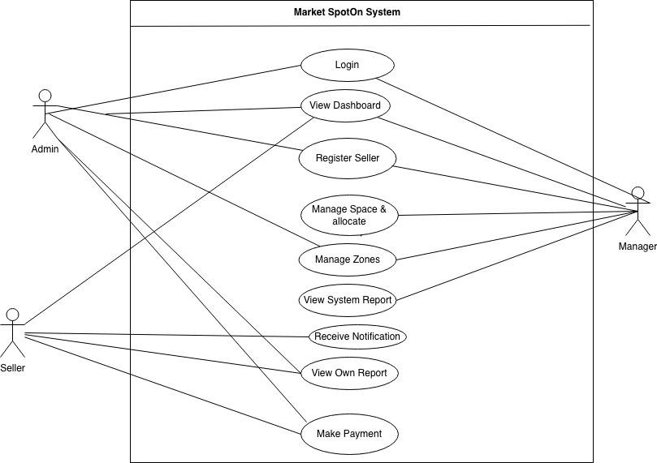

Figure 2. Use case diagram

Use Case Description

A Use Case description specifies what a use case accomplishes, and what it requires to be properly performed. Each use case is documented using the following structure:
- Name: A unique identifier for the use case

- Description: A brief explanation of what the system aims to accomplish through this use case
- Actor: The primary participant(s) involved in the use case

- Precondition: The system state required before the use case may start

- Post-condition: The system state after the use case is successfully completed

- Normal Flow: The primary sequence of steps describing the standard scenario

- Alternative Flow: Variations or exception conditions that could occur during execution

Use Case Number | UC-01
Use Case Name | User Registration and Authentication
Actor | Vendor, Market Administrator
Description | Creating a new account or logging into the Market SpotOn System
Pre-condition | - A user must have a valid email address or phone number  - For registration: required business documentation must be available
Post-condition | - A user will have secure access to the system with appropriate role-based permissions

Normal Flow | - Login  - User enters credentials (username/email and password)  - System verifies credentials and grants access  - View Profile  - User can view and verify their account information  - Update Account  - User can modify personal and business information  - Access Dashboard  - User views personalized dashboard with relevant market information  - Manage Market Activities  - Vendors: view space allocations, make payments, check announcements  - Administrators: manage vendors, allocate spaces, generate reports  - View and Download Documents  - Access receipts, allocation letters, and market reports
Alternative Flow | - If login credentials are invalid, the system displays an error message and allows retry  - If registration data is incomplete, the system prompts for missing information  - If account already exists during registration, system suggests password recovery  - If system encounters database error, transaction is rolled back and user is notified

Table 1: Adding users Use Case Table

Use case description for the admin

Use Case Number | UC-02
Use Case Name | Manage Users
Actor | Market Administrator
Description | Managing vendor accounts and administrator access within the Market  SpotOn System
Pre-condition | - Administrator must be logged into the system  - Administrator must have appropriate administrative privileges
Post-condition | - User accounts are properly created, updated, or deactivated as required  - All changes are logged in the system audit trail
Normal Flow | - View User Accounts  - Administrator accesses the user management dashboard  - System displays list of all registered vendors and administrators  - Create New User Accounts  - Administrator initiates new account creation  - System displays registration form  - Administrator enters required user information  - System validates and creates new account  - Edit User Profiles  - Administrator selects user account to modify  - System displays current user information  - Administrator makes necessary changes  - System updates user profile  - Activate/Deactivate Accounts  - Administrator selects account status change

- System confirms the action
- Account status is updated accordingly
- Reset User Passwords
  - Administrator initiates password reset for specific user
  - System generates temporary password
  - User receives notification to set new password
Alternative Flow | - If duplicate account is detected during creation, system alerts administrator and suggests merging options  - If required information is missing, system highlights missing fields and prevents submission  - If system encounters database error during update, changes are rolled back and administrator is notified  - If administrator attempts to modify their own account privileges, additional verification is required

Table 2: Admin Use Case Table

Use case description for Backend side

Use Case  Number | UC-03
Use Case Name | Automated Space Allocation
Actor | Backend
Description | Automatically allocate market spaces to vendors based on predefined rules  and availability
Pre-condition | - Space inventory data is loaded and current  - Vendor applications and preferences are submitted  - Allocation rules and business logic are configured

Post-condition | - Vendors are assigned optimal spaces based on business rules  - Space occupancy records are updated in real-time  - Allocation results are logged for audit purposes
Normal Flow | - Retrieve Space Availability  - System queries current space occupancy status  - Identifies available spaces by zone and category  - Process Vendor Applications  - System retrieves pending vendor applications  - Analyzes vendor preferences and business categories  - Apply Allocation Rules  - Execute rule-based allocation algorithm  - Consider factors like vendor seniority, payment history, business type  - Generate Optimal Allocation  - Assign spaces to qualified vendors  - Ensure optimal space utilization across market zones  - Update System Records  - Update space occupancy status  - Generate allocation notifications for vendors  - Generate Allocation Report  - Create summary of allocation results  - Update dashboard metrics
Alternative Flow | - If no suitable spaces are available, system flags application for manual review and notifies administrator  - If conflicting allocations are detected, system triggers conflict resolution protocol  - If data validation fails, system rolls back transaction and logs error  for technical review

- If system encounters database connection issues, retry mechanism is activated with exponential backoff

Table 3: Backend side Table

Class Diagram
A class diagram serves as a fundamental component of software modeling and design in the field of software engineering. It provides a visual representation of the building blocks of the Market SpotOn System, aiding in the understanding and planning of the software architecture. Within a class diagram, each class typically consists of three key elements: attributes, operations (methods), and associations. Attributes represent the properties or data members of a class, while operations define the behaviors or functions that the class can perform. Associations illustrate the relationships and connections between classes, allowing designers to depict how different classes interact within the system and influence one another's behavior.
In UML, class diagrams play a crucial role in modeling the static structure of the Market SpotOn System. They not only reveal the relationships between classes but also showcase source code dependencies, inheritance hierarchies, and interface implementations. This makes class diagrams an indispensable tool for both high-level architectural design and low-level coding details, bridging the gap between abstract design and concrete implementation while ensuring consistency and traceability throughout the development process.
Class diagrams are applicable to various object-oriented programming languages and paradigms, such as Java, C++, and Python. They offer a blueprint for creating, maintaining, and understanding the Market SpotOn System by presenting a clear hierarchy of classes and their associations, improving both development efficiency and collaboration among diverse project team members and stakeholders across the software development lifecycle.

Class Diagram
The class diagram represents the static structure of the Market SpotOn System, showing its main classes, attributes, and relationships.
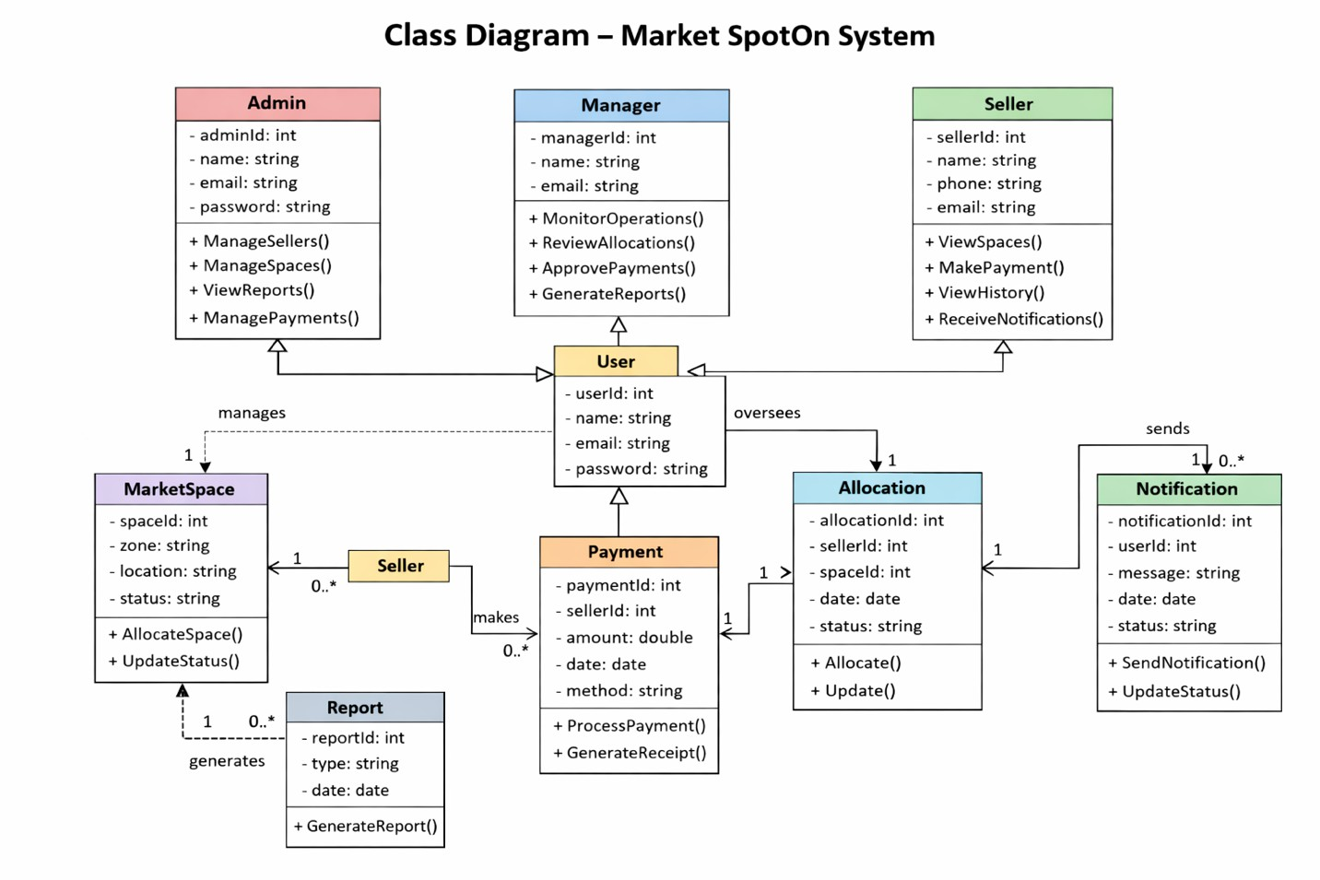
Figure 3: Class diagram

Sequence Diagram

A sequence diagram is a type of interaction diagram that depicts objects as lifelines running down the page, with messages rendered as arrows from the source lifeline to the target lifeline, representing their interactions through time. Object interactions are arranged in temporal sequence in a sequence diagram.
In UML, the stages required to perform an operation are described in sequence diagrams, which are interaction diagrams. They show how objects interact when operating within a cooperative system. Sequence Diagrams are time-focused and use the vertical axis of the diagram to indicate time, what messages are received when, and how the interaction is organized graphically.

The notations and their definitions that are used in sequence diagram

Term and Definition | Symbol
Actor:  - Could be a person or external system that interacts with but is not part of the system  - Participates in interactions by sending and/or receiving messages  - Positioned at the top of the diagram | 
Object Lifeline:  - Represents an object that participates in a sequence by sending and/or receiving messages  - Shows the lifespan of the object during the interaction  - Placed vertically in the diagram with object name at top | 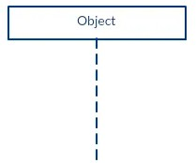

Activation Box:  - A narrow rectangle positioned on top of a lifeline  - Indicates when an object is active and performing an operation  - Shows the period of message transmission and reception | 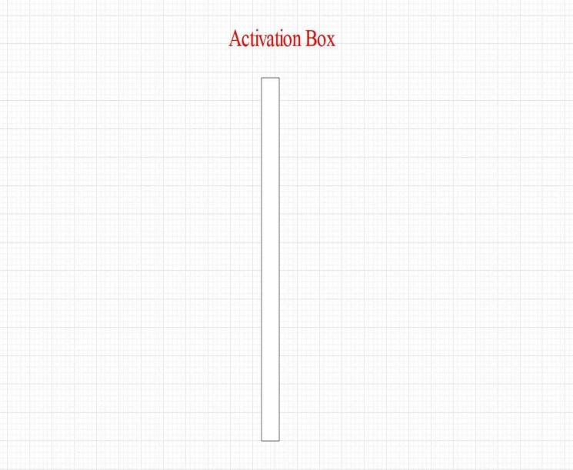
Message:  - Synchronous Message: Solid arrow with filled head → Carries information and waits for response  - Asynchronous Message: Solid arrow with line head → Sends message without waiting  - Return Message: Dashed arrow  ←┃ Indicates response or return value  - Creation Message: Dashed arrow with "new" → Object instantiation  - Destruction Message: Solid arrow with X → Object deletion | 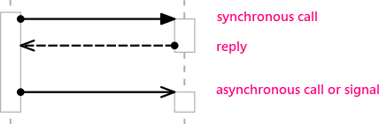
Table 4: Sequence diagram Table

User Signup and Login Process

The SpotOn system provides a secure and streamlined process for user registration and authentication. New users whether Admin, Manager, or Seller can sign up by providing their personal and business information, which is validated and securely stored in the system database. During login, users enter their credentials, which are verified against stored records. Upon successful authentication, the system grants access to role-specific functionalities: Admins manage spaces, sellers, and payments; Managers monitor operations and approvals; Sellers view spaces, make payments, and receive notifications. This process ensures secure access, protects sensitive data, and directs users to the appropriate interface based on their role.
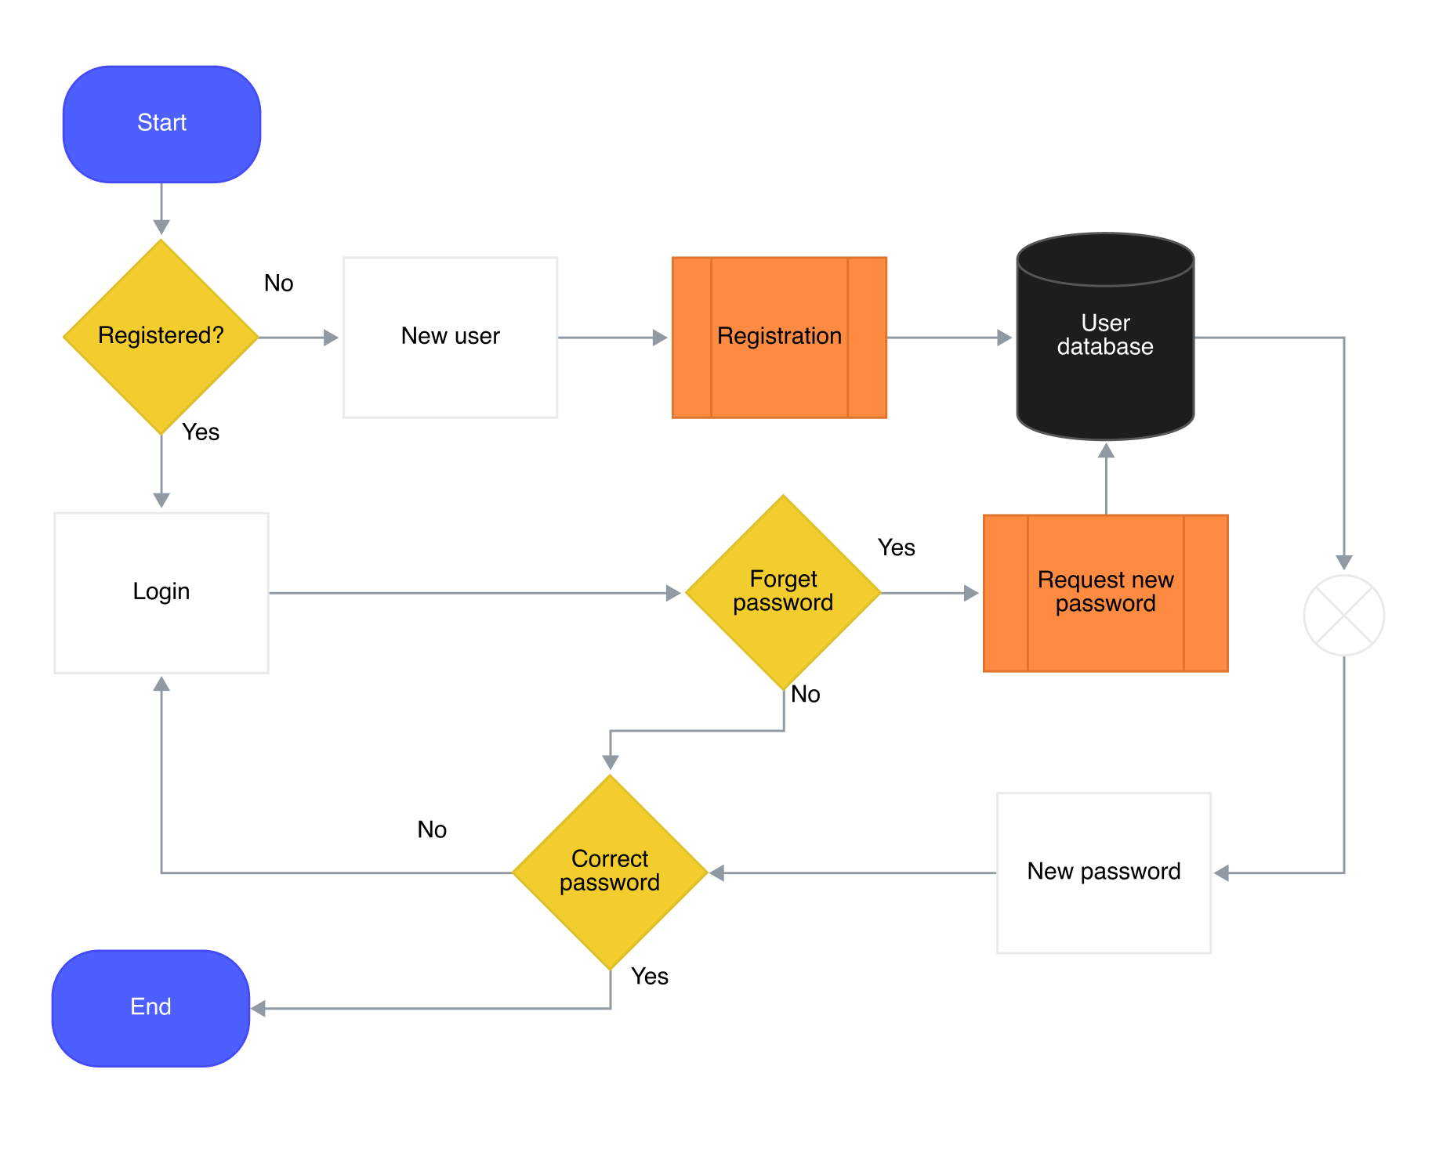

Figure 4: Sequence Diagram

Process Interpretation:

- The account creation process begins with submitting user information, validating its format, and checking if the account already exists in the database.

- If the information format is incorrect, an error message is shown to the user. If the account already exists, a corresponding error message is displayed prompting the user to login or recover their account.
- For valid and non-duplicate information, the user account is saved in the database, and the system automatically redirects to the login process for authentication.
- The login process involves entering credentials, validating their format against stored records, and granting system access if successful. If validation fails, the system shows an authentication error and provides password recovery options.

Prediction sequence diagram:
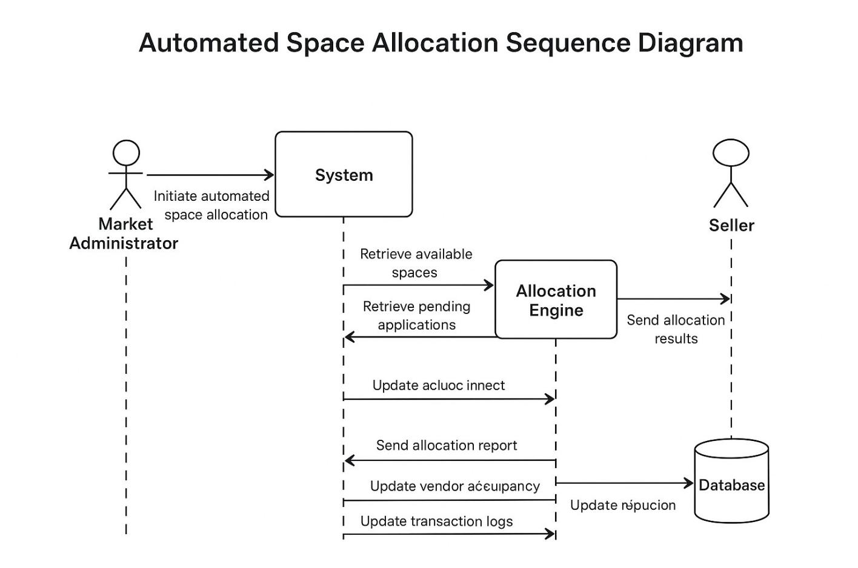

Figure 5: Prediction sequence diagram

- The system begins with login and role validation, where user credentials are verified, and the Market Administrator or Vendor role is determined.

- It proceeds to vendor and space data validation, ensuring all submitted vendor details and available market spaces are valid. If inconsistencies are detected, the system flags them for manual review.
- A system readiness and payment verification check follows, confirming that the vendor’s payment status and allocation conditions meet system requirements. Error notifications are displayed if issues arise.
- Once validations are complete, the system retrieves available spaces and pending vendor applications.
- The Allocation Engine processes these inputs to match vendor requirements with available spaces, applying allocation rules such as business type, seniority, and payment history.
- The Notification System then sends allocation results to vendors and a detailed allocation report to the Market Administrator.
- Finally, the Database updates all relevant records, including space occupancy, vendor allocation details, and transaction logs for future tracking and reporting.

Activity Diagram

An activity diagram is a type of UML diagram that illustrates the workflow of the Market SpotOn System processes. It shows the sequence of activities, decision points, and parallel processes, highlighting the flow of control from one task to another. Activity diagrams help visualize market management processes, clarify responsibilities among actors, and identify potential improvements by providing a detailed view of the system's behavior.

Key Elements in Market SpotOn Context:

Activities:

- Definition: Market management tasks or operations performed in the workflow

- Notation: Rounded rectangles

Actions:

- Definition: A single step within an activity that cannot be broken down further

- Notation: Rounded rectangles

Initial Node (Start Node):

- Definition: The starting point of the market workflow

- Notation: Filled black circle

Final Node (End Node):

- Definition: The end point of the workflow

- Notation: Filled black circle inside a larger unfilled circle

Decision Nodes:

- Definition: Points where the workflow branches based on conditions

- Notation: Diamond shape

Merge Nodes:

- Definition: Points where multiple branches converge back into a single flow

- Notation: Diamond shape

Fork Nodes:

- Definition: Points where a single flow splits into multiple concurrent flows

- Notation: Thick horizontal or vertical bar with multiple outgoing arrows

Join Nodes:

- Definition: Points where multiple concurrent flows synchronize back into a single flow

- Notation: Thick horizontal or vertical bar with multiple incoming arrows

Swim lanes:

- Definition: Partition the activity diagram to represent different actors (Vendor, Administrator, System)

- Notation: Vertical or horizontal sections

Transitions (Edges):

- Definition: Arrows that show the flow of control from one activity or action to another

- Notation: Arrows connecting elements

Signals and Events:

- Definition: Represent asynchronous triggers or external inputs affecting the workflow

- Notation: Special icons or symbols

User Account Creation and Login Process
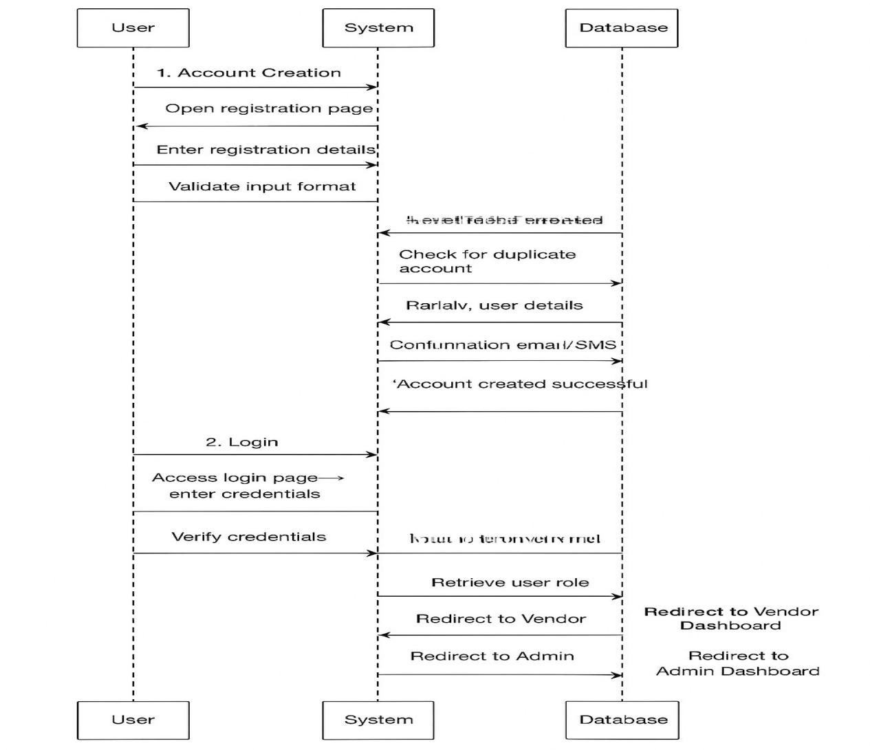

Figure 6: User signup and login activity diagram

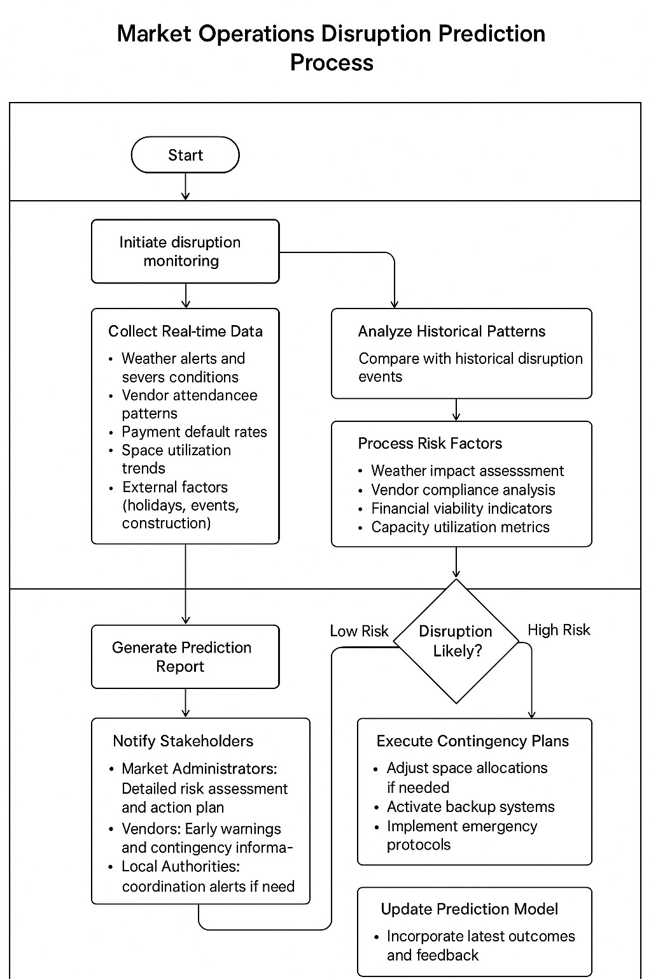

Figure 7 Prediction activity diagram.

Database Schema Diagram
A database schema diagram describes how data is organized to create a blueprint for how a database will be constructed and is the database management system's supporting formal language used to define the structure of a database system (DBMS). Formally speaking, a database schema is a set of rules (sentences referred to as integrity constraints) applied to a database. The compatibility of the schema's components is ensured by these integrity requirements.
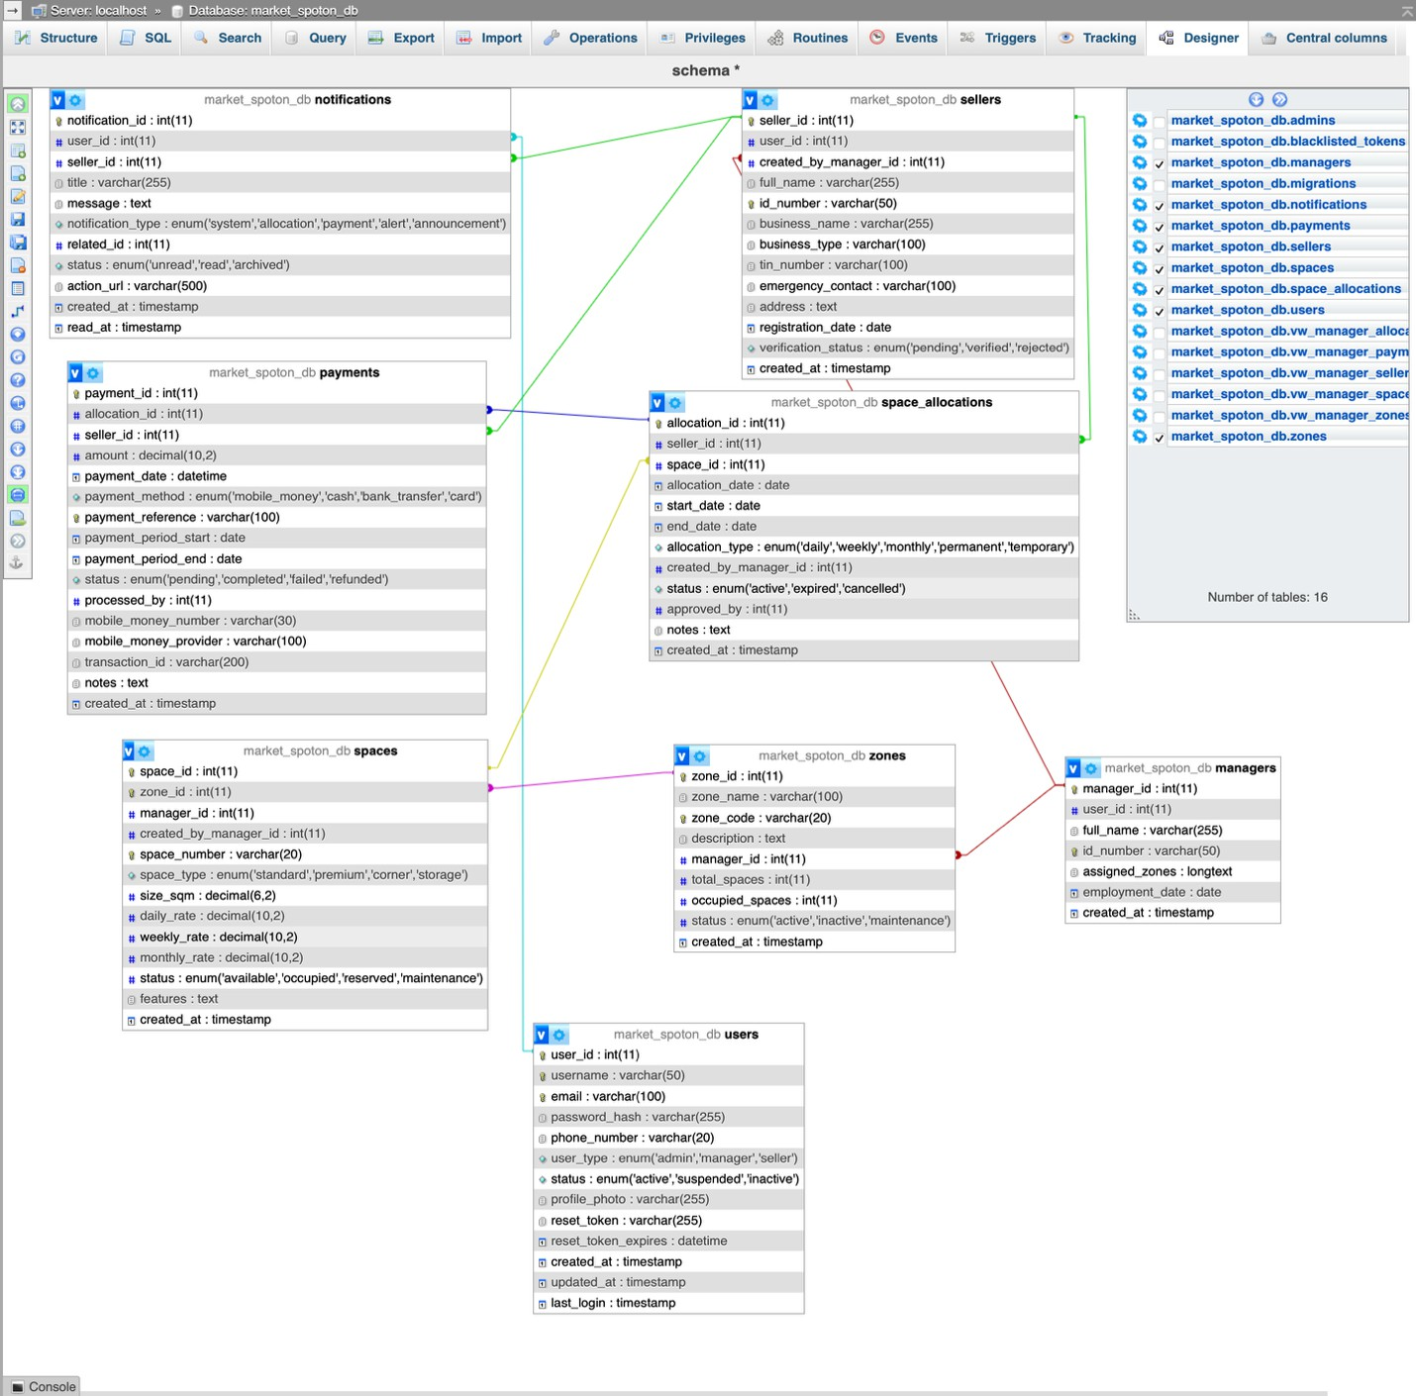
Figure 8 Database schema

Data Dictionary
A data dictionary serves as a vital component in the field of data management and database design. Its role extends beyond assisting programmers and includes supporting a wide range of stakeholders, from data analysts to database administrators, and even end-users. When designing or evaluating a system that involves user-interactive objects, the initial phase requires a comprehensive understanding of each object's attributes and its relationships with other objects.
This understanding helps in creating a clear and accurate data model that serves as the foundation for effective system design. A well-maintained data dictionary acts as a living document that evolves with the system. It serves as a reference point throughout the entire software development lifecycle, aiding in system maintenance, troubleshooting, and future enhancements. As systems grow in complexity, the data dictionary plays a pivotal role in managing data consistency and ensuring that all stakeholders share a common understanding of the data's meaning and usage.

User account

Field Name | Data Type | Description
user_id | INT, Primary Key, Auto Increment | Unique identifier for each  user
username | VARCHAR (30), Unique | User’s login name
email | VARCHAR (30), Unique | User’s email address
password_hash | VARCHAR (50) | Hashed password for  security
phone_number | VARCHAR(15) | User’s contact number
role | ENUM('vendor','market_admin','finance_officer') | Role of the user in the  system
is_active | BOOLEAN, Default: TRUE | Indicates if the user  account is active
created_at | TIMESTAMP | Account creation  timestamp
last_login | TIMESTAMP | Last login timestamp

The figure above shows:
The User account Data Dictionary provides detailed descriptions of the attributes stored within the user database table
Spaces Table

Field Name | Data Type | Description
space_id | INT, Primary Key, Auto Increment | Unique identifier for each market  space
space_number | VARCHAR(20), Unique | Identifier or code for the space
size | VARCHAR(30) | Size or dimensions of the space
location | VARCHAR(50) | Location description within the  market
monthly_rate | DECIMAL(10,2) | Charge for renting the space per  month
status | ENUM('available','occupied','maintenance') | Current status of the space
created_at | TIMESTAMP | Timestamp when the space was  added
updated_at | TIMESTAMP | Last update timestamp

3. Sellers Table

Field Name | Data Type | Description
seller_id | INT, Primary Key, Auto Increment | Unique identifier for each seller
user_id | INT, Foreign Key → Users(user_id) | Links seller to a user account
full_name | VARCHAR (100) | Seller’s full name
phone_number | VARCHAR (20) | Seller’s contact number
national_id | VARCHAR (20), Unique | National identification number
created_at | TIMESTAMP | Seller registration timestamp
updated_at | TIMESTAMP | Last update timestamp

Payments Table

Field Name | Data Type | Description
payment_id | INT, Primary Key, Auto Increment | Unique identifier for  each payment
seller_id | INT, Foreign Key → Sellers(seller_id) | Which seller made the  payment
space_id | INT, Foreign Key → Spaces(space_id) | Space the payment is for
amount | DECIMAL(10,2) | Payment amount
payment_date | TIMESTAMP | When the payment was  made
payment_method | ENUM('mobile_money','cash','bank_transfer') | Method used for  payment
status | ENUM('pending','completed','failed') | Payment status
confirmation_code | VARCHAR(50) | Unique code confirming  the payment

Reports Table

Field Name | Data Type | Description
report_id | INT, Primary Key, Auto  Increment | Unique identifier for each report
report_type | ENUM('daily','monthly') | Type of report
generated_by | INT, Foreign Key →  Users(user_id) | User who generated the report
generated_at | TIMESTAMP | Timestamp when the report was created
content | TEXT | Detailed report content (could be JSON, CSV,  or text)

System architecture diagram

The system architecture of Market SpotOn illustrates how the platform’s components interact to deliver a seamless and efficient market management experience.
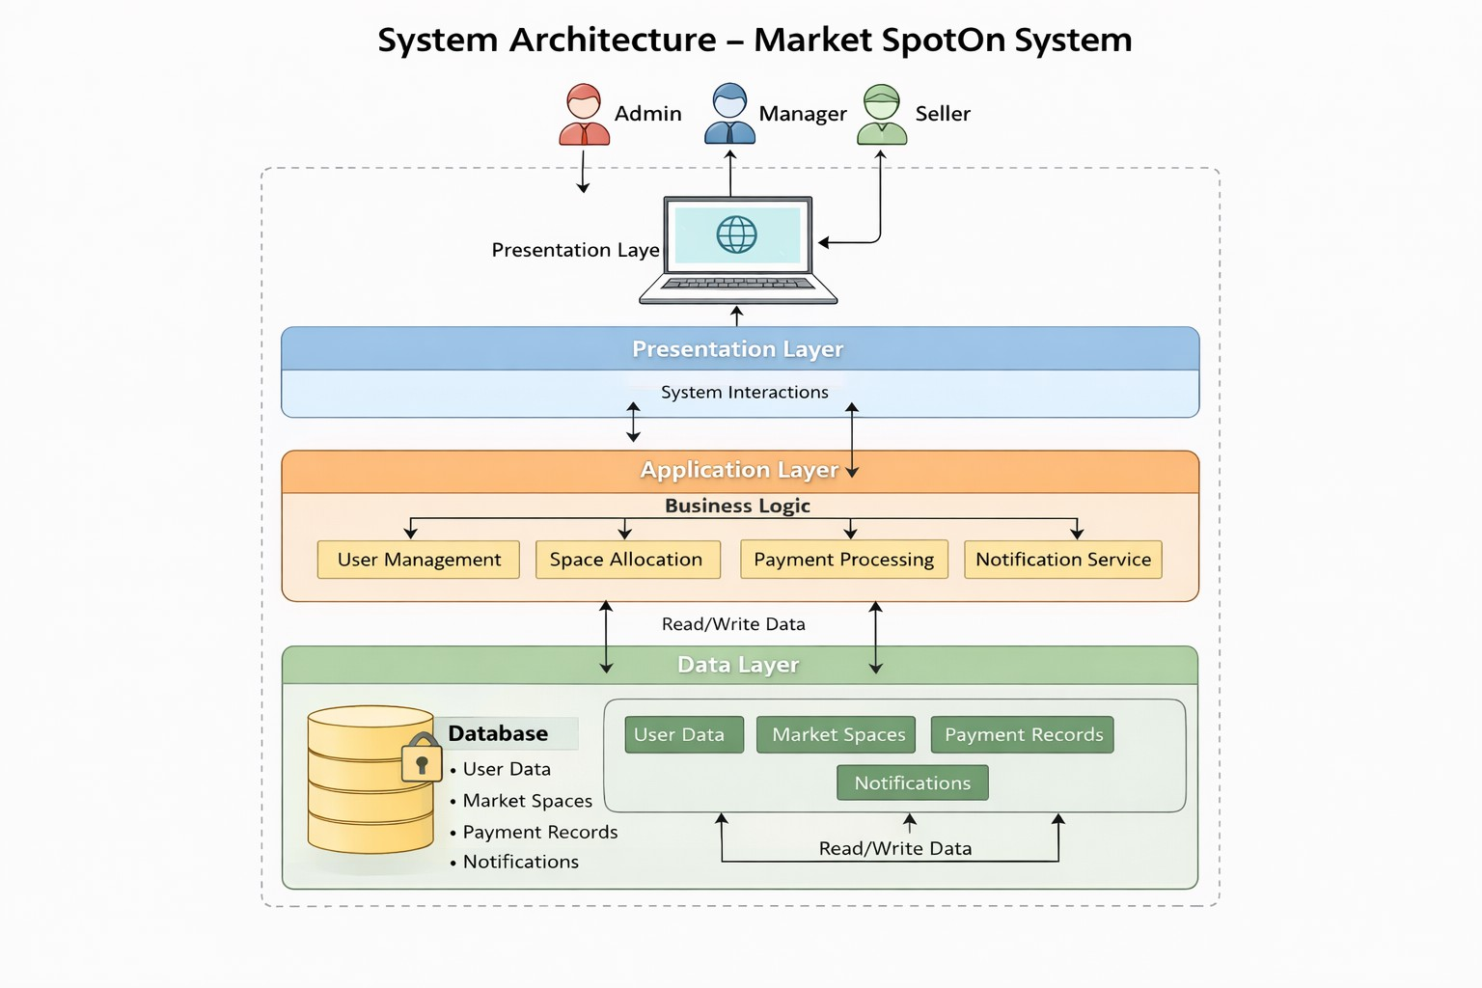

Figure 9: System architecture

CHAPTER 4

IMPLEMENTATION OF THE MARKET SPOTON SYSTEM

Introduction
This chapter presents the implementation of the Market SpotOn System, a web-based digital platform developed to streamline market management processes. Building on the requirements, analysis, and architectural designs established in earlier chapters, this section explains how conceptual models were transformed into a fully operational platform. It outlines the technologies, development tools, backend and frontend environments, and integration processes used to build the system, ensuring alignment with the operational needs of market authorities and vendors.

The implementation phase focused on digitizing existing manual workflows, including market space allocation, seller registration, payment processing, reporting, and communication, into structured, automated, and traceable system operations. Modern web technologies were selected based on their reliability, scalability, and suitability for handling real-time data in enterprise-level market operations. The development strategy followed software engineering best practices, emphasizing modular design, maintainability, security, and interoperability.

This chapter also discusses the integration of user-interface components, backend services, and the database layer, highlighting how these elements work together to support role-based access, space management, payment tracking, notifications, and reporting. Testing procedures ensured that the system performs correctly, securely, and consistently under real operating conditions. Functional, integration, and performance testing were conducted to validate key modules such as user authentication, space allocation, seller onboarding, payment processing, and automated notifications.

Finally, the chapter presents the hardware and software specifications required for deployment, maintenance, and future scaling of the platform. By detailing the full implementation process from technology selection to testing this chapter demonstrates how the Market SpotOn System evolved into a robust, user-centered web platform capable of enhancing efficiency, transparency, and accountability in market operations

Technologies Used
To build the robust, user-friendly web and mobile-responsive platform for the Market SpotOn System, a modern technology stack was selected, prioritizing scalability, security, and a smooth developer experience. The implementation utilized the following tools and technologies:

Front-End Development:
- React.js: This open-source JavaScript library was used to build the dynamic and responsive user interfaces for both admin and seller dashboards. Its component-based architecture allowed for the creation of reusable UI elements such as space allocation maps, payment forms, and report widgets, ensuring a consistent and maintainable codebase for complex features like real-time space tracking. (Dan & Rachel, 2023)
- CSS3 with Tailwind Framework: For styling and responsive design, CSS3 was employed in conjunction with the Tailwind CSS framework. This utility-first approach enabled rapid, consistent UI development that works seamlessly across devices—from the market manager's desktop to the seller's mobile phone—ensuring accessibility for all users. (Developers, 2024)
- Visual Studio Code: As the primary integrated development environment (IDE), VS Code provided a powerful and efficient environment for writing, debugging, and version- controlling the front-end code. Its extensive extensions and built-in Git support streamlined the development workflow. (Vs Code, 2024)
- JavaScript (ES6+): Modern JavaScript was the core programming language for implementing interactive features on the client side, including form validations during seller registration, dynamic updates of the zone availability map, and handling real-time notifications. (Propel, 2024)

Back-End & Database Development:
- TypeScript & Node.js: The server-side logic of the Market SpotOn System was developed using TypeScript with Node.js. This combination was chosen for its performance, scalability, and ability to build efficient, production-ready RESTful APIs. Node.js enabled rapid development of critical modules such as user authentication, payment processing, and automated report generation, while TypeScript added type safety and improved maintainability across the system.

- XAMPP with MySQL: For the database layer, XAMPP (Apache, MySQL) was utilized as the local development environment. The MySQL relational database management system was selected to handle the platform's structured data. MySQL's proven reliability, transactional support, and efficient performance make it ideal for managing the system's core transactional data—including seller profiles, payment records, space allocations, and audit logs. This ensures data integrity and consistency for critical financial and operational reporting. The bundled Apache server within XAMPP provided a stable environment for testing the full application stack during development.

- Payment Gateway APIs: Secure integrations with popular mobile money and digital payment service providers (e.g., MTN Mobile Money, Airtel Money) were implemented using their official REST APIs. This allows for secure transaction initiation, status verification, and automated receipt generation within the system.

Presentation of the New System
This section illustrates the results of the implementation of Market SpotOn system. The following are some of the user interfaces and web pages that result from running the codes:
Landing Page
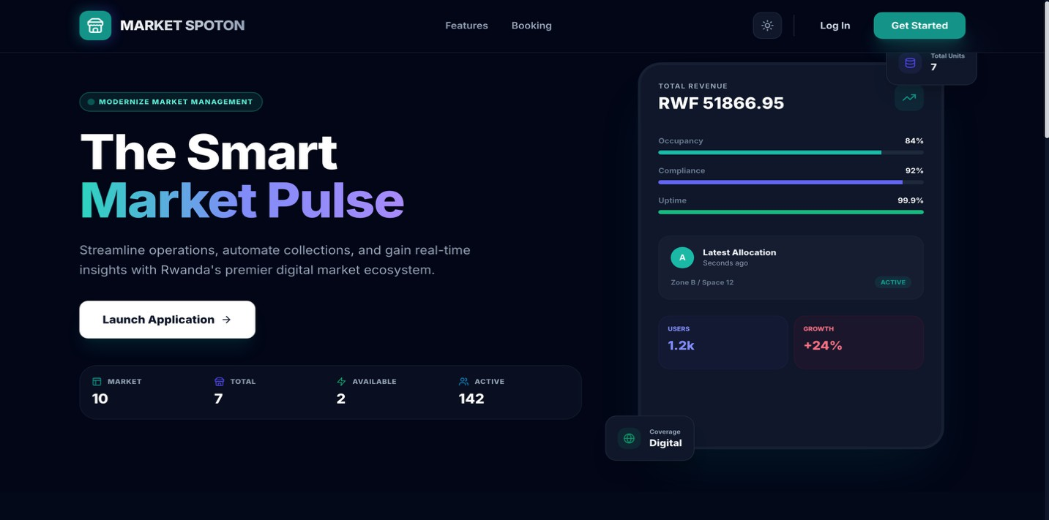

Login Page:

A secure login interface for all users of the system to access the system.


Figure 10: Login Page

Admin Dashboard page :

A comprehensive dashboard for admin to providing an overview of the whole system.
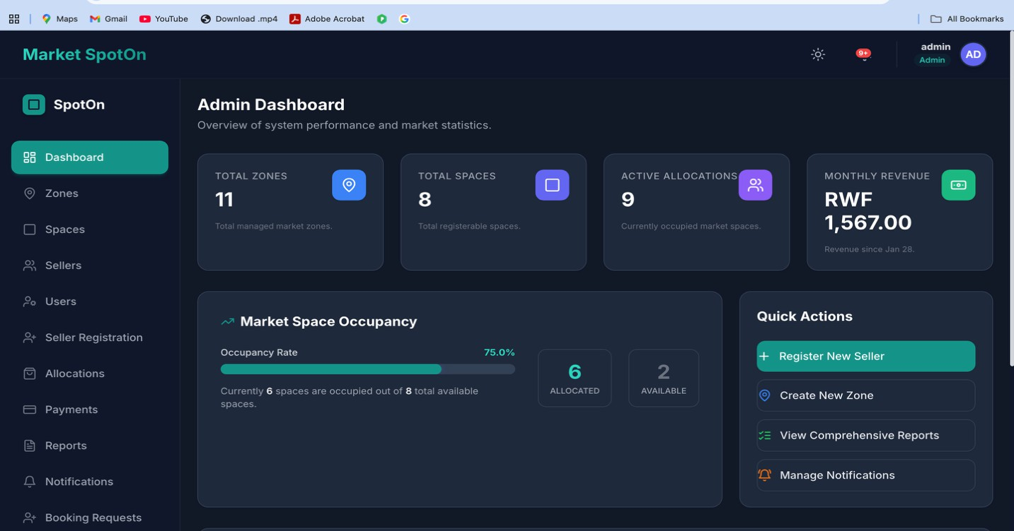
Figure 11: Admin Dashboard

Zone Pages

This interface allows administrators to efficiently organize, monitor, and manage the physical layout of the marketplace with precision and clarity.
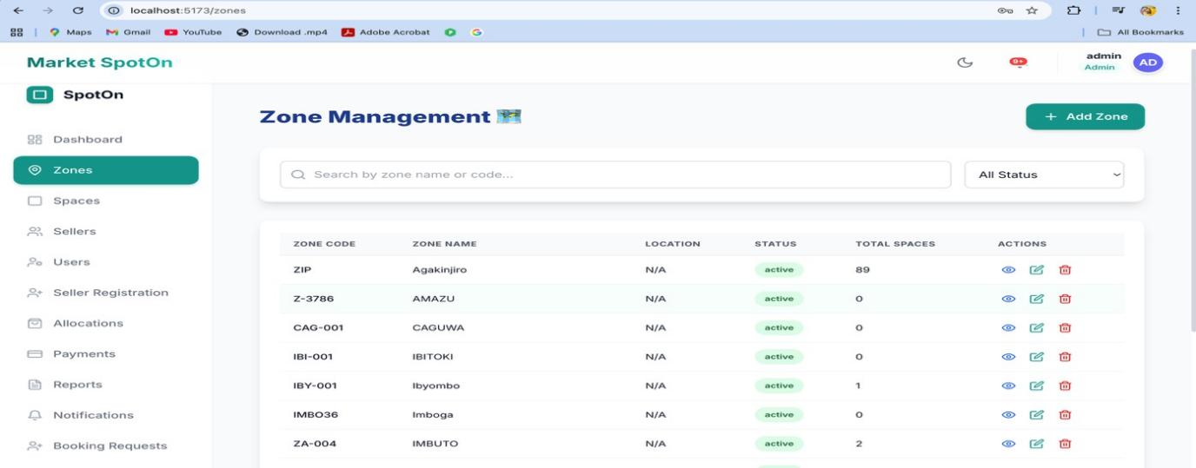

Figure 12: Zone Page

Space Management

This interface enables administrators to manage, price, and monitor every stall, kiosk, or spot with precision translating physical market assets into efficiently.
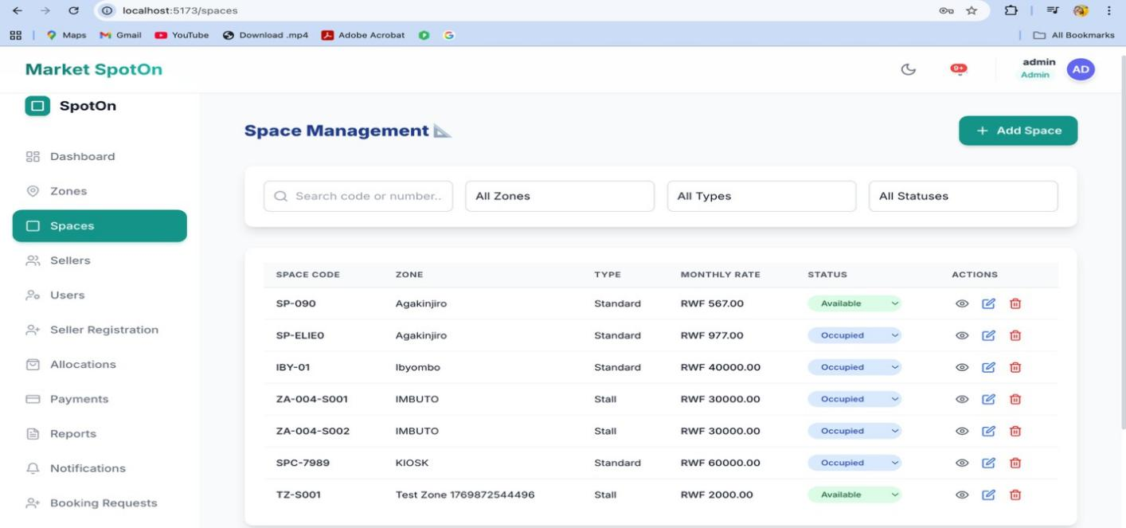

Figure 13: Space Management Page

Report
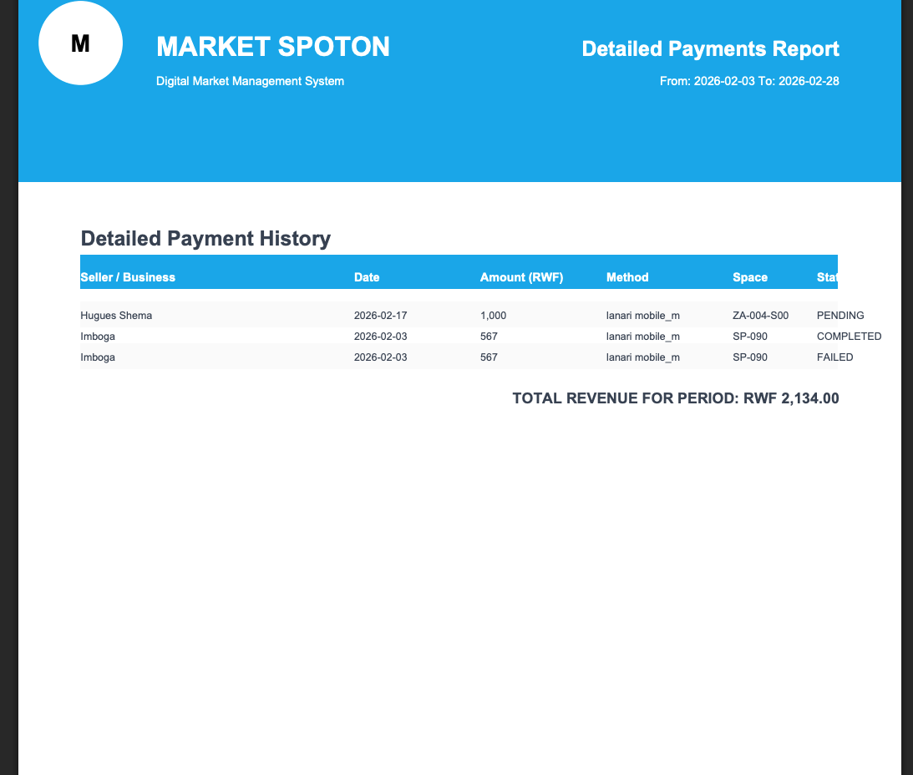
Figure 14: Report

Software Testing

The design of software benefits from the use of software tests. They aid in determining whether the software genuinely accomplishes the task it was designed to tackle.

When undertaking software testing, it's vital to keep the following things in mind:

- Is the application compliant with the standards that guided its design and development?
- Is the application functioning as it should?
- Is it possible to implement the application in the same way and satisfy the needs of the stakeholders?

The following are some software testing techniques:

The Unit Test: Unit testing is a technique for ensuring the correct operation of a particular piece of software or a program. It is a method of evaluating the acceptability for use of individual pieces of source code, sets of one or more computer program modules, related control data, usage processes, and operating procedures. In other words, every little component that can be assembled with the aim of verifying that each part is in accordance with its specifications and checking for logical errors Unit testing is a powerful tool that allows for the most thorough error detection. At every point where code has been created, a unit test has been run on the application.
The Integration test: is the stage of software testing where many software components are combined and tested together. This test is crucial for confirming the correct assembly of the software's numerous components. As more tests are run, the hardware and software components are gathered and tested, and eventually the full system is tested. The application modules were thoroughly tested one after another until they were finished to guarantee that the assembled software components met all of the necessary functional and technical requirements.
The Validation test: The software is validated in its external context during the final test step. To guarantee that it fully satisfies the requirements established in the beginning phase, the product has been tested in its final configuration. The validation test is essential to make sure that the setup of the application corresponds to the needs stated. For instance, the national ID must contain 16

digits, and the email address must begin with @ and conclude with yahoo.com or gmail.com. The application was thoroughly tested, and it was during this process that we discovered that the operations' progress matched the functional requirements.

Hardware and Software Requirements
Client-Side Software Requirements:
- A web browser (Google Chrome, Mozilla Firefox, Opera, etc.)
- Operating System (minimum Windows11; Linux, Mac OS).
- A RAM of 4 GB (minimum)
- A hard disk of minimum 8 Gigabyte of free space

Server-Side Software Requirements:
- Operating System: minimum Windows Server 2008 Enterprise.
- XAMPP;
- Network cark: 1GB/Second;
- RAM: 4GB minimum;

CHAPTER 5

CONCLUSION AND RECOMMENDATIONS

Conclusion

The Market SpotOn System has been designed and developed to directly address the critical operational challenges of inefficiency, lack of transparency, and administrative burden inherent in traditional, manual market management. As marketplaces serve as vital economic and social hubs, the need for a modern, digital platform that streamlines operations for market authorities while empowering sellers has never been more pressing. This system provides a centralized solution that replaces fragmented paper-based processes, enhancing operational control, financial accountability, and trust within the market ecosystem.

Throughout the development of the Market SpotOn System, the core focus was on bridging the gap between market management objectives and seller needs through automation and real-time information. Analysis of existing manual methods revealed significant pain points: opaque space allocation, cash-based revenue collection prone to leakage, and poor communication channels. The system was engineered to solve these problems by leveraging a modern, robust technology stack including React.js for an intuitive interface, Spring Boot for secure business logic, and MySQL for reliable data management to create a scalable and user-centric platform.

The implementation of this system is projected to fundamentally transform daily market administration and seller experience. By delivering key features such as real-time Zone & Space Management, a seamless Seller Registration workflow, a secure Integrated Payment System, and automated Comprehensive Reporting, the Market SpotOn System will not only optimize revenue collection and space utilization but also establish a new standard of transparency. The platform's Automated Notifications and dual User Dashboards ensure all stakeholders are informed and engaged, reducing conflicts and building a more cooperative and efficient marketplace.

Recommendations
To enhance the effectiveness and sustainability of the Market SpotOn System, the following recommendations are proposed based on the system design outcomes and the operational context of market management. These recommendations focus on improving system utilization, strengthening operational performance, and guiding future improvements to support efficient, transparent, and accountable market operations.

To Market Authorities:

- Provide targeted training for administrators and managers to ensure smooth adoption and effective daily use of the platform.
- Enhance IT infrastructure by investing in secure servers, reliable internet connectivity, and robust cybersecurity measures to protect sensitive vendor and financial data while maintaining stable system performance.
- Gradually expand the platform’s functionality to additional areas, such as vendor performance analytics, advanced reporting, and multi-market integration, to further reduce manual processes and promote a fully digital market ecosystem.

For Future Research and Development:

- Consider developing additional modules, such as a mobile-friendly interface or progressive web app, to allow sellers and managers to access allocations, payments, and notifications on the go, improving flexibility and real-time communication.
- Explore the integration of Artificial Intelligence (AI) to optimize space allocation, predict high-demand zones, and identify potential revenue opportunities, helping market authorities make data-driven decisions.
- Focus on user experience and system compliance improvements, including session management, data privacy compliance, and enhanced authentication features, to strengthen security and adherence to modern web standards.

REFERENCES

Books
Alan, D., Barbara, W. H., & David, T. (2009). Systems Analysis and Design with UML Version 2.0. John Wiley & Sons, Inc.
Chishti, I. M., & Knight, B. (2014). Ontology mapping of business process modeling based on formal temporal logic. International Journal of Advanced Computer Science and Applications, 95–104.
Dittman, K. C. (2004). Systems Analysis and Design Methods. McGraw-Hill.

Jhangiani, R. S., Chiang, I.-C. A., Cuttler, C., & Leighton, D. C. (2019). Research Methods in Psychology. Kwantlen Polytechnic University.
Nixon, R. (2009). Learning PHP, MySQL, and JavaScript. O’Reilly Media.

Scott, W. A., & Larman, C. (2000). The Unified Process: Inception Phase. CRC Press.

Sikha Bagui, & Earp, R. E. (2003). Database Design Using Entity-Relationship Diagrams. Auerbach Publications.
University of Karlskrona/Ronneby. (1998). Software Architecture: An Overview of the State-of- the-Art. Psilander Grafiska.
Websites
Amar, H. A. (2020, June 4). Six critical phases of the Systems Development Life Cycle (SDLC). UNI Tanzania. https://unitanzania.com/the-systems-development-life-cycle-sdlc/
IBM. (n.d.). What is software testing? IBM. https://www.ibm.com/topics/software-testing

Jotform. (2021). Data Collection Methods. Jotform Education. https://www.jotform.com

MySQL. (n.d.). What is MySQL? Oracle Corporation. https://dev.mysql.com/doc/refman/8.0/en/what-is-mysql.html
SmartDraw. (2021). Class Diagram. https://www.smartdraw.com/class-diagram/

Reports and Journal Articles
Alan, D., Barbara, W. H., & David, T. (2009). Systems Analysis and Design with UML Version
2.0. John Wiley & Sons, Inc.

Dittman, K. C. (2004). Systems Analysis and Design Methods. McGraw-Hill.

Ambler, S. W., & Larman, C. (2000). The Unified Process: Inception Phase. CRC Press, Boca Raton.
Bagui, S., & Earp, R. E. (2003). Database Design Using Entity-Relationship Diagrams. Auerbach Publications, New York.
University of Karlskrona/Ronneby. (1998). Software Architecture: An Overview of the State-of- the-Art. Psilander Grafiska, Karlskrona, Sweden.
Quizlet. (n.d.). Chapter 6 Discussion. Retrieved from https://quizlet.com/570847270/ch-6- discussion-flash-cards/

APPENDICES

Curriculum Vitae



Data Collection Letter


Case study organisation Approval Letter



